**CMPE 273 – Enterprise Distributed Systems**

**Lab 2**

**(MongoDB and RabbitMQ)**

**Sneha Jain**

010694697

Fall 2015

1. **Introduction**

The following report contains description about MyFacebook, a working prototype of Social networking application (Facebook like). The application facilitates users to do all of the following:

* Create and update his profile
* Share his status updates on his timeline
* Connect to friends on the portal (Send and Accept friend requests)
* View his news feed, which has posts shared by all his friends
* View his friends’ timeline, interests, profile and their friend list
* Create/Delete groups and add/remove members to the group
* Join groups created and followed by other members
* Create interests of his choice and add it to his profile interest, and also make it available for other users to add the same

Furthermore, following are some more details about the application:

* The application was developed using RabbitMQ which uses a Message Oriented Middleware (MOM) to implement Asynchronous Message Queueing Protocol (AMQP).
* The application has a separate client (Producer) and server (Consumer). The client publishes messages to queues that are then routed to the subscribers (the server side here). The subscribers listen on specific queues for messages.
* A separate queue is maintained for every functionality, namely, login, user, friend, posts, interests, groups. The structure can be modified depending on the user usage patterns to better balance queue load
* The application uses RESTful services using Node.js and AngularJS.
* User sessions are maintained through server sessions using MongoDB.
* User passwords are stored in a hashed form. The Hash function used is SHA512, which used the original password and email id (SALT) to create the hashed form of the password.

1. **System Design**

The application was developed using the following technologies:

* Server: Node.js Server (Express)
* Model: Javascript
* Views: EJS, AnguladJS, Bootstrap
* Controller: Node.js
* Database: MongoDB

Node modules:

* For client: amqp, connect-mongo, ejs, express, express-session, mongodb
* For Server: amqp, async, mongodb,

1. **Results** (Screen Shots)

Following is the list of functionalities tested and results captured (screenshots are added below in the same order)

* **User Login**
  + Login Page: User logs in using his email id and password. Password are hashed at the client and then sent to server for check. Password are saved in the hashed form in the database
  + Incorrect login credentials: Warning appears on incorrect login
  + Signup functionality: Present on login page, below the Nav-bar. User requires to fill in firstname, lastname, sex, unique email id and password. All fields are madatory
  + Warning on using existing email id on signup: If user signs-up with an email id already signed up with MyFacebook
* **User Homepage**: Has a navigation bar at the top with four options, namely:
  + Timeline
    - View all his posts till date in descending order
    - Create Post: User shared his thoughts with his friends on this timeline
    - Create multiline posts: Application accepts multi-line posts and symbols in input
  + About
    - View (Life events in descending order): View this details with Phone number, Date of Birth, Employment, Education, Description and Life-Events
    - Edit: Edit existing details, none of the fields are mandatory as the user may not want to share some of his details
    - Cancel: Cancel edit option
    - Date of Birth Validation: Edit functionality doesn’t accept invalid date
    - Add Life event: Add new life events with title, description and event date
    - Add Event Validation: Event title and time fields are required and event date must be valid
  + Friends
    - Current friends
      * View Current friend list, friends whose requests user has accepted and vice versa
      * Unfriend option to remove user as friend, using the unfriend option
      * Search box for list to search from a long list
    - Friend Requests
      * Accept request: View list of requests from other users
      * Search box for list to search from a long list
  + Interest
    - View Interests selected earlier
    - Search interest by type: Search bar each interest added separately
    - Add Interest: Add interest from result
    - Remove interest: Remove interest previously selected

One can access user Home Page by Clicking his name from the nav-bar right corner

* **View News Feed**
  + Click on Home option on top right corner
  + List of posts from friends and self (descending order of create time)
  + Can create new posts: Same as homepage create post functionality
* **Search Bar** (In the Navigation Bar)
  + Search for Groups and Users: Enter name to searched
  + List of results displayed: Displays list of matching groups and Users. Check done against user firstname/lastname and group name/description
  + Click on user/group to view respective profile
* **Groups**:

(Access groups page from nav-bar dropdown menu)

Has four navigation tabs namely:

* + Create Group
    - User can create a new group
    - Group name mandatory
    - Add members to groups using search bar in create group
    - Cancel option create group details
  + Your Groups
    - View list of groups created by user himself
    - Go to group profile page by clicking on group-name
    - Search box to search from long list
  + Your Other groups
    - View list of groups user is a member od
    - Go to group profile page by clicking on group-name
    - Search box to search from long list
  + Friends Groups (List of groups that user’s friends have created or are a member of and user is not a member of. Groups listed in descending order of popularity. Groups with more members will be listed above groups with lesser members)
    - View list groups user is not a part of
    - Go to group profile page by clicking on group-name
    - Search box to search from long list
* **Group Profile**
  + View: Different views implemented
    - Creator of the group will have edit option
    - Member of the group will have Leave Group option
    - Outsider will have Join group option
    - Outsider can’t view Members of a group, only group-name, description and creator
  + Join a group
  + Edit
    - Add/Delete Members
    - Group name cannot be null validation
  + Leave a group
  + Delete a group (Only for creator of the group)
* **View friend**
  + Timeline: Views posts from friend
  + About: View friend’s profile details
  + Friends: View friend’s friends
  + Interests: View friend’s interests
* **User friend requests**:
  + Send friend request
  + Respond to friend request
    - Accept friend request
    - Reject friend request
  + Change pending request
* **Create Interest**
* **About page**: About the application
* Access user profile or group profile by clicking on respective links anywhere in the application
* **Exception Handling**:
  + No such user
  + No such group
  + Page doesn’t exist
  + Login required

Screen-shots

* User Login
  + Login Page: User logs in using his email id and password. Password are hashed at the client and then sent to server for check. Password are saved in the hashed form in the database

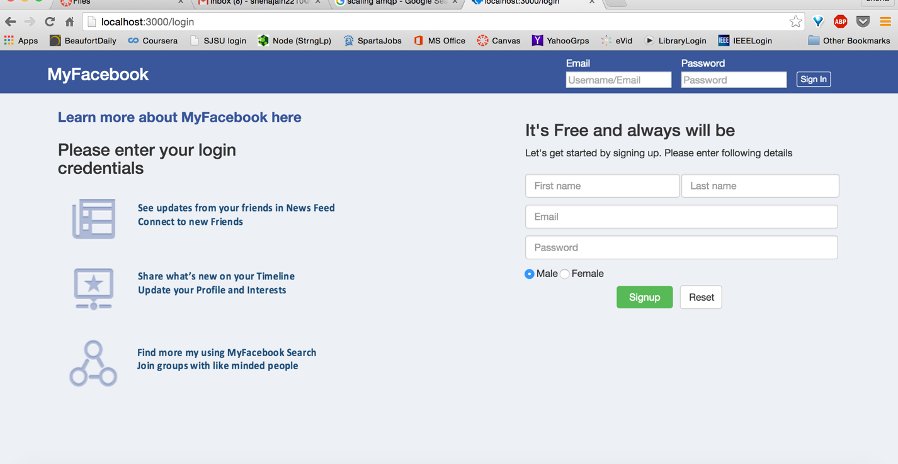

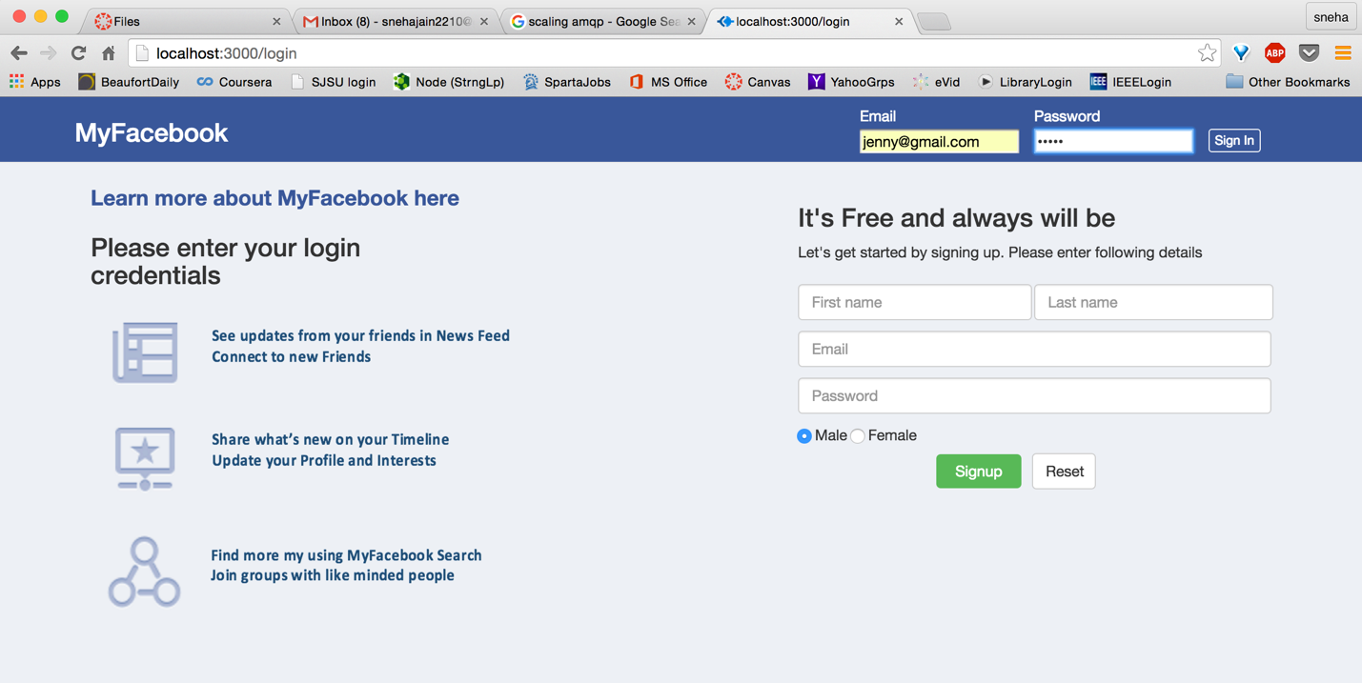

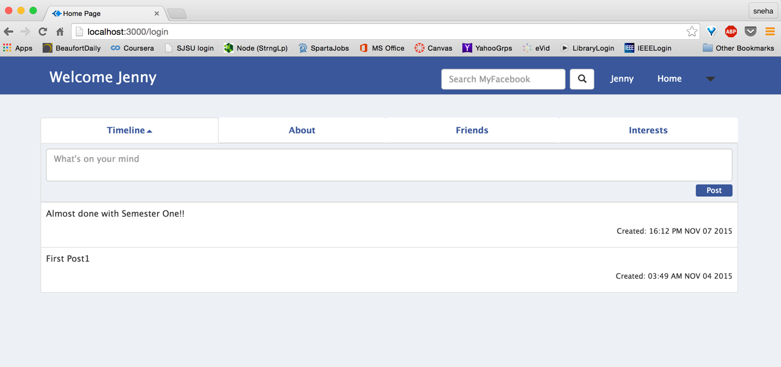

* + Incorrect login credentials: Warning appears on incorrect login

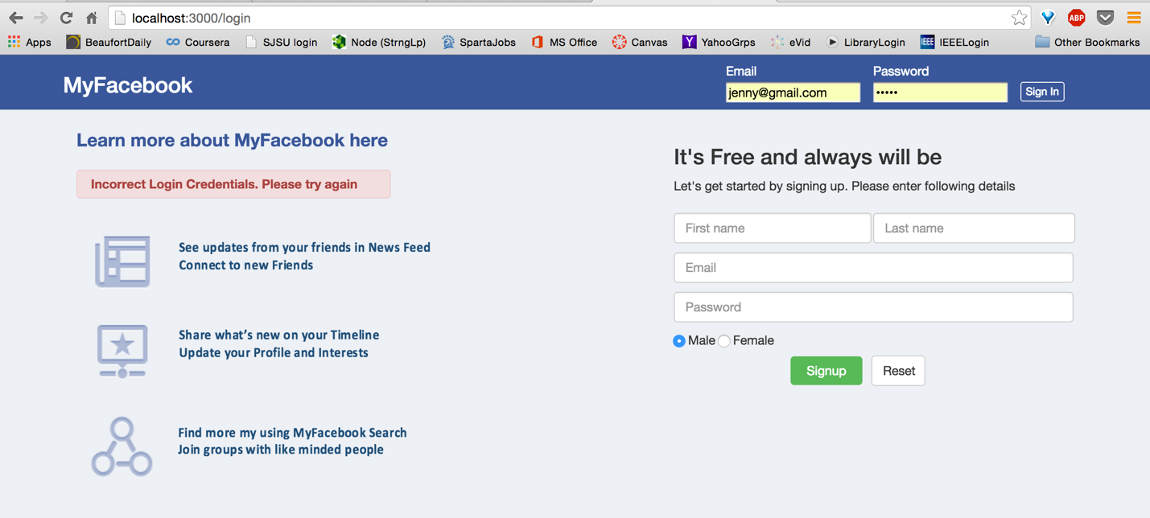

* + Signup functionality: Present on login page, below the Nav-bar. User requires to fill in firstname, lastname, sex, unique email id and password. All fields are mandatory

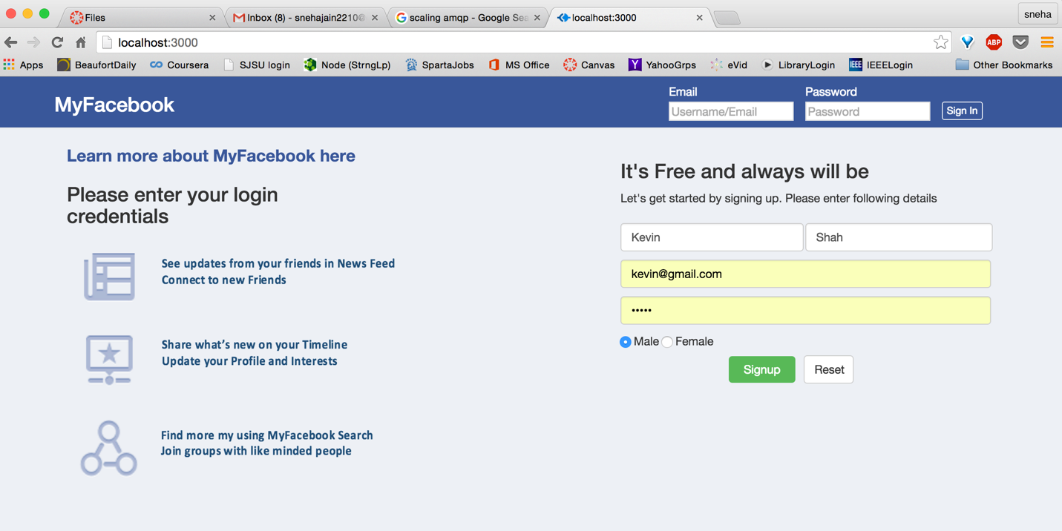

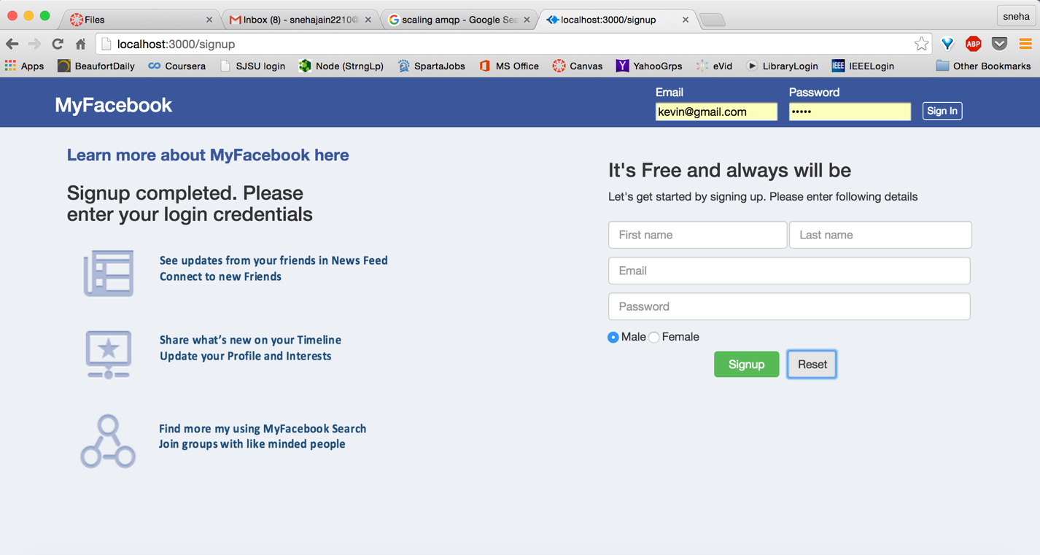

Confirmation on completing signup. Enter login credentials to access application

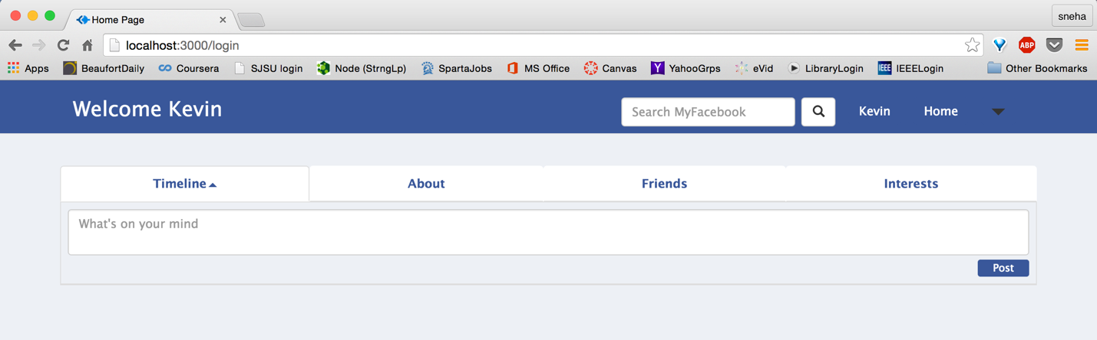

* + Warning on using existing email id on signup: If user signs-up with an email id already signed up with MyFacebook

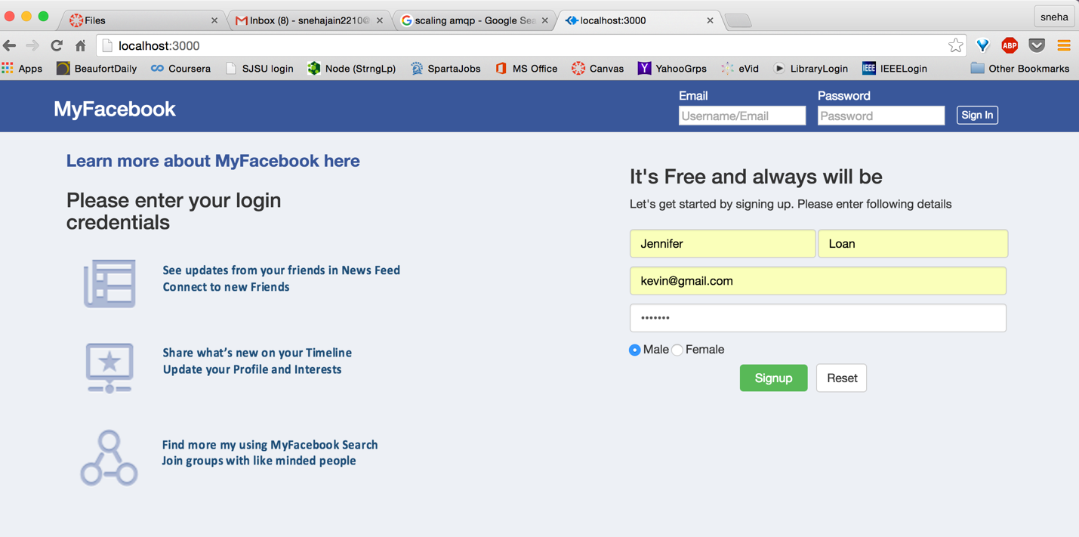

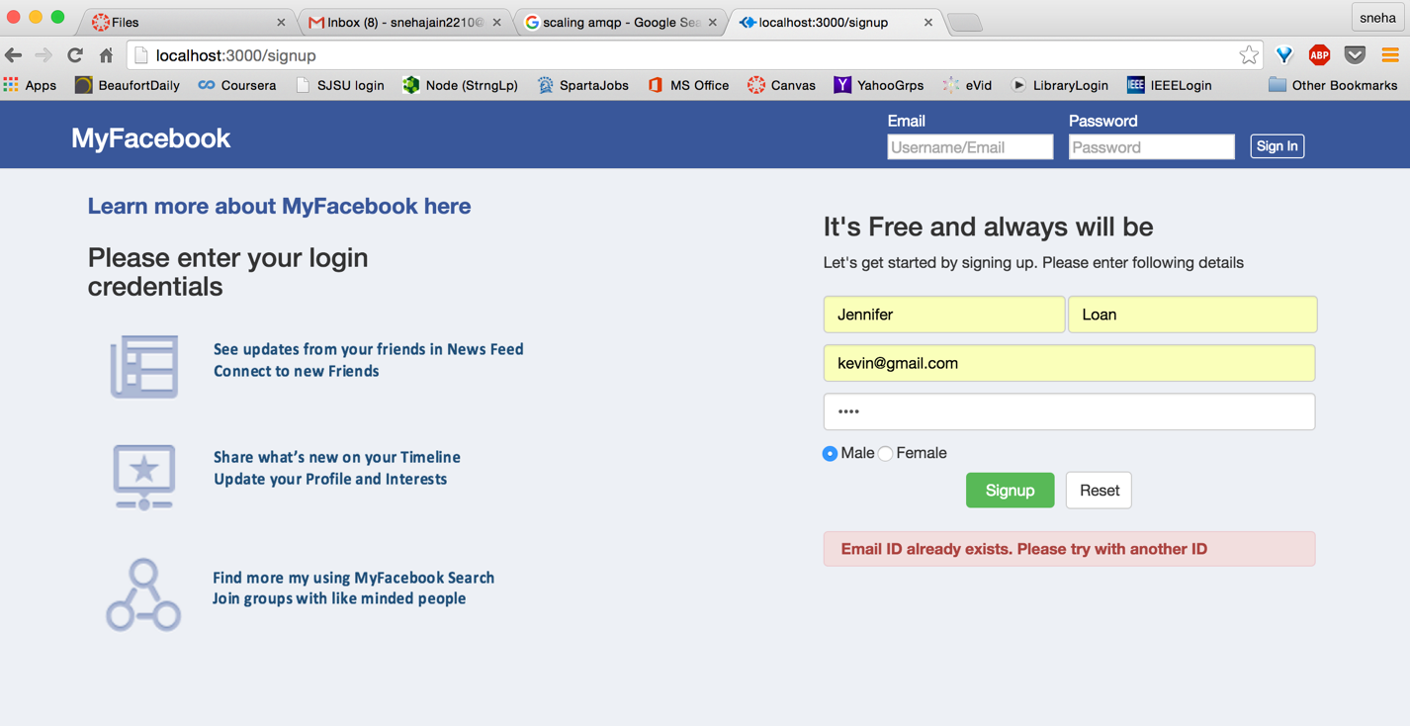

* + Logout

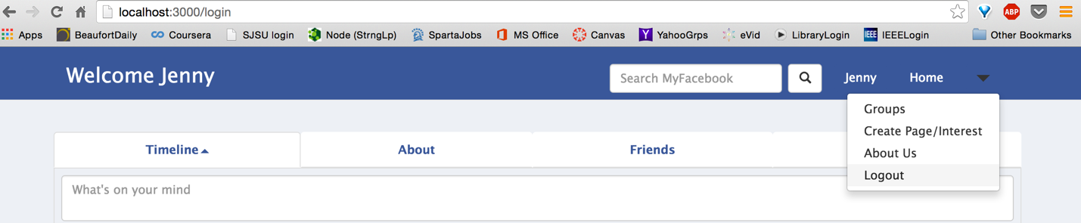

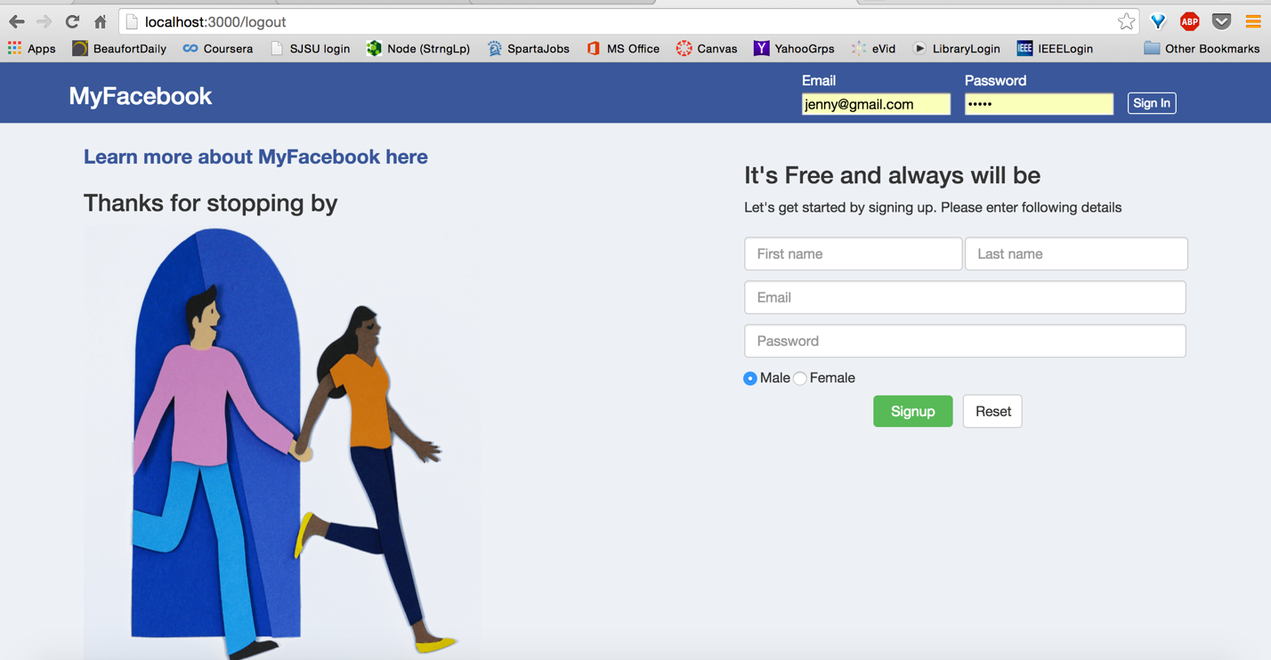

* User Homepage: Has a navigation bar at the top with four options, namely:
  + Timeline
    - View all his posts till date in descending order

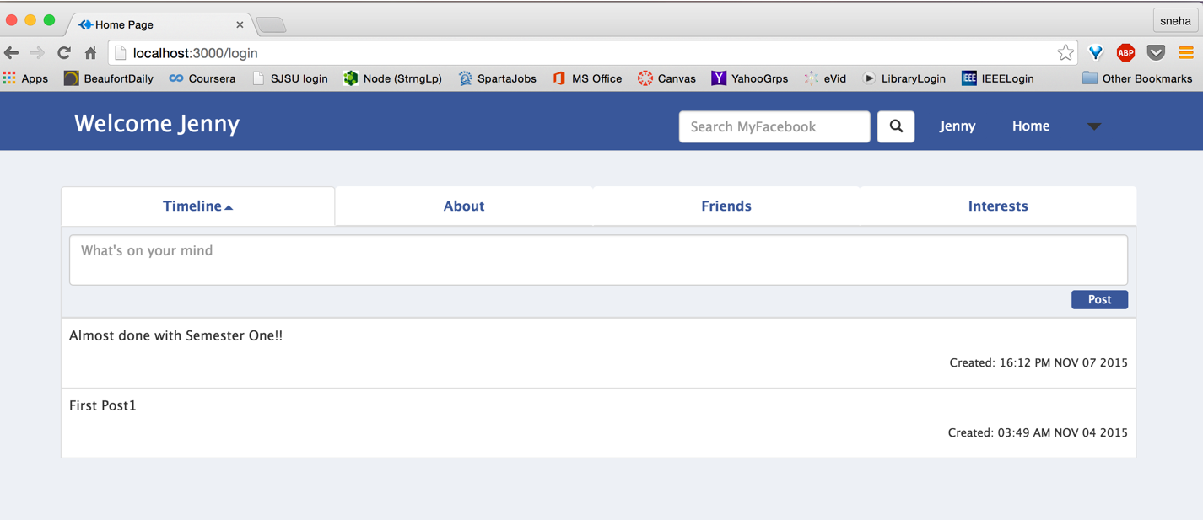

* + - Create Post: User shared his thoughts with his friends on this timeline

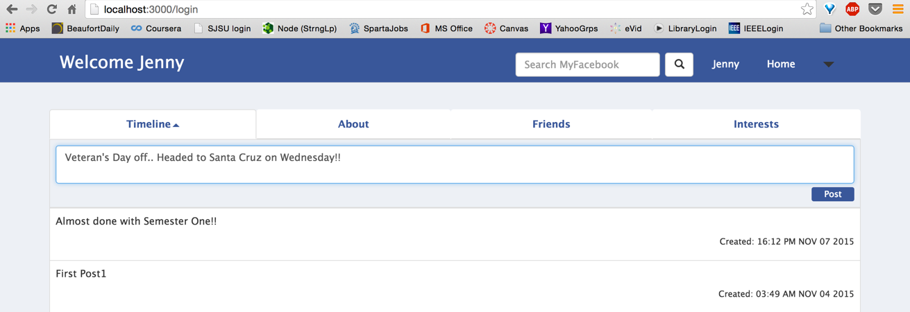

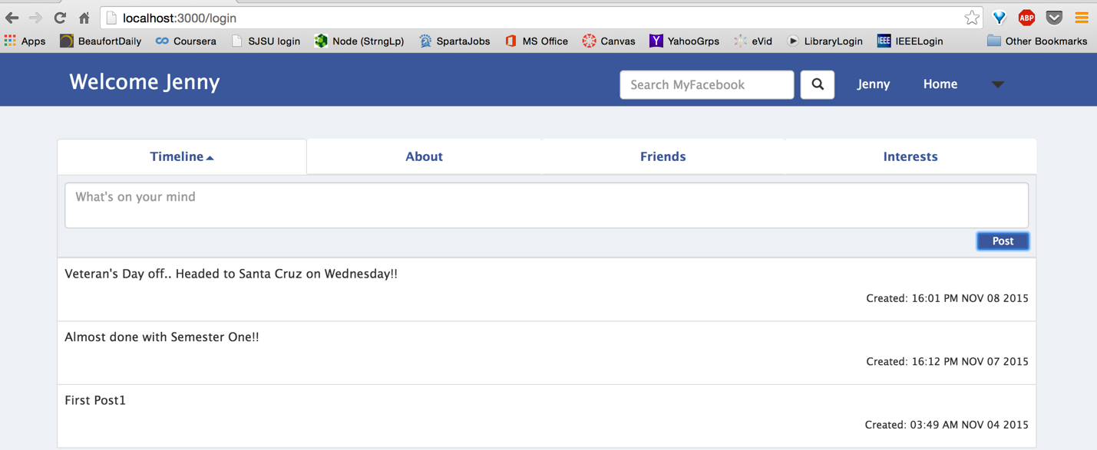

* + - Create multiline posts: Application accepts multi-line posts and symbols in input

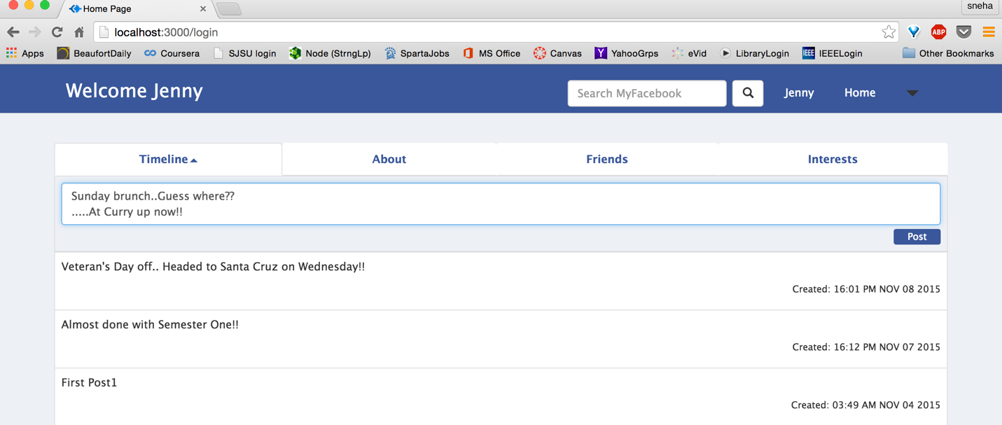

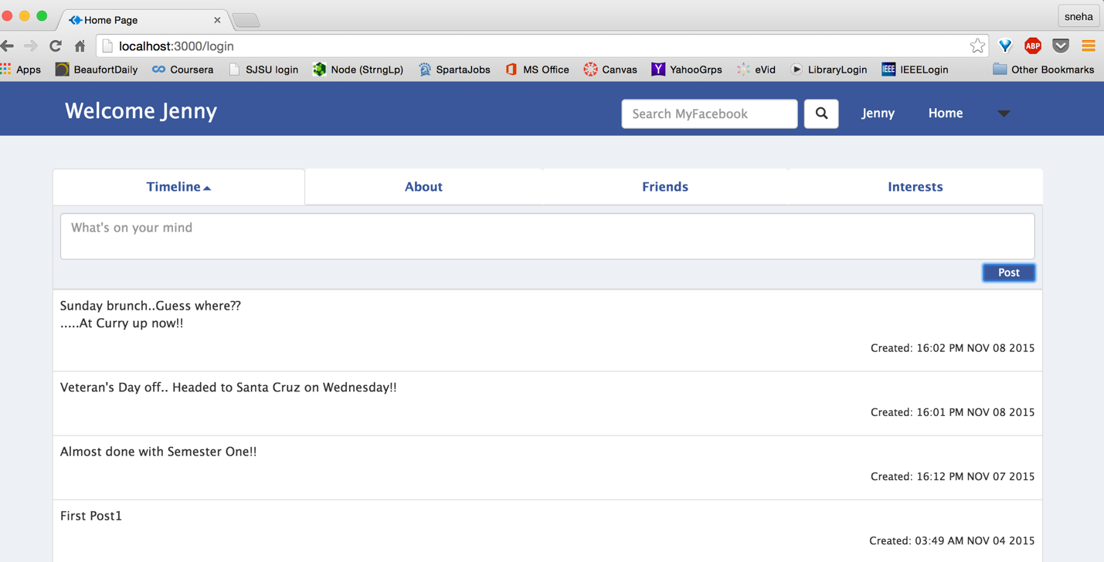

* + About
    - View (Life events in descending order): View this details with Phone number, Date of Birth, Employment, Education, Description and Life-Events

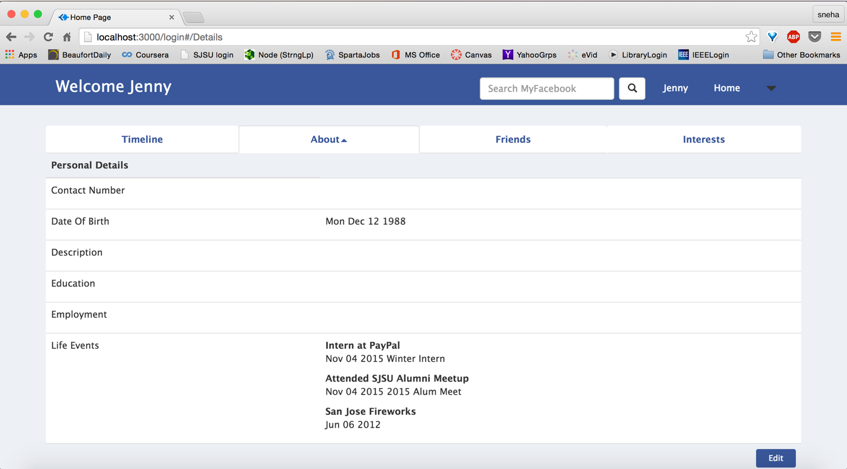

* + - Edit: Edit existing details, none of the fields are mandatory as the user may not want to share some of his details

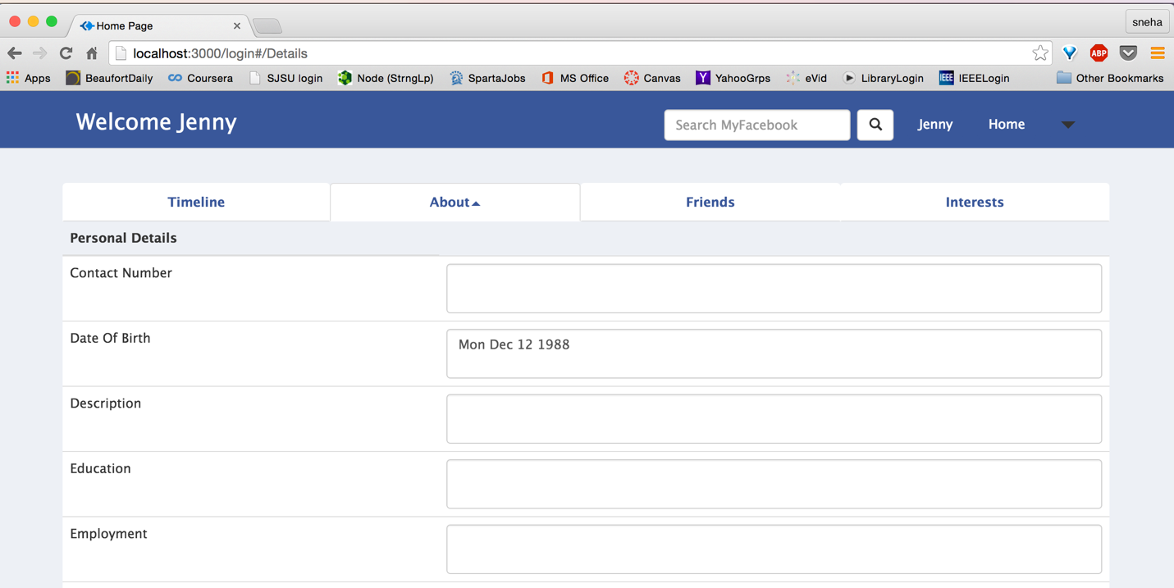

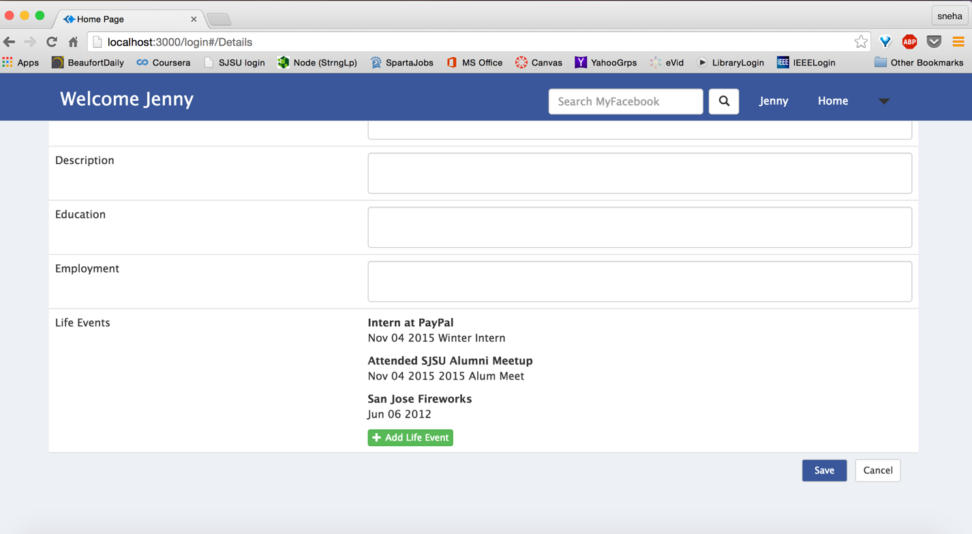

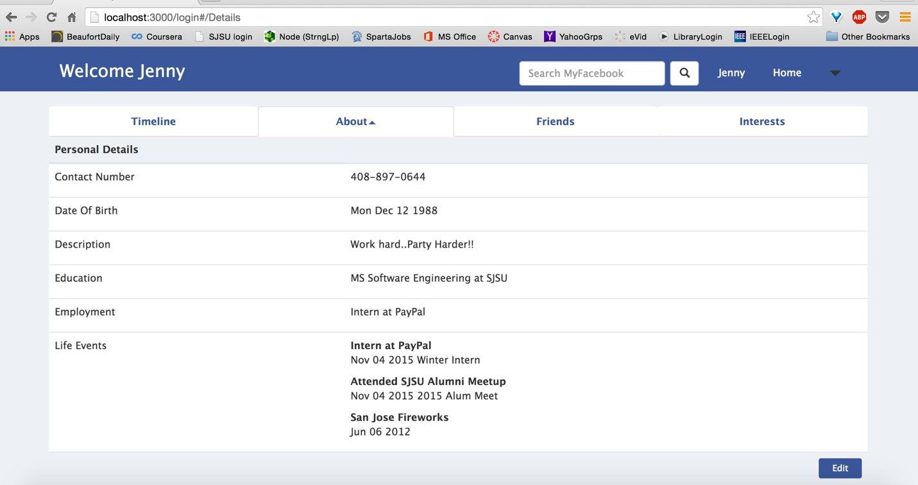

* + - Cancel: Cancel edit option

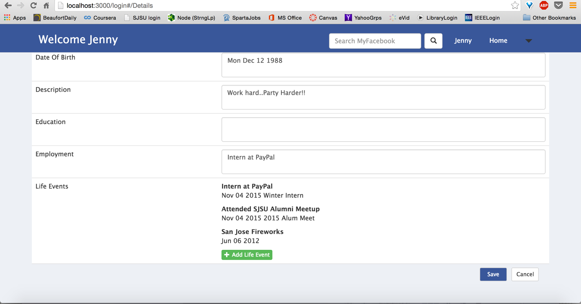

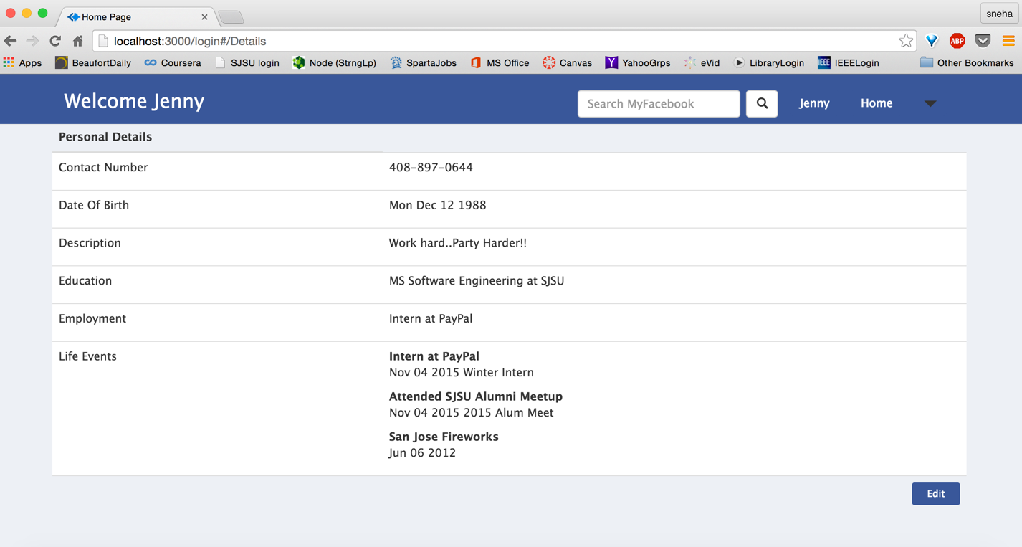

* + - Date of Birth Validation: Edit functionality doesn’t accept invalid date

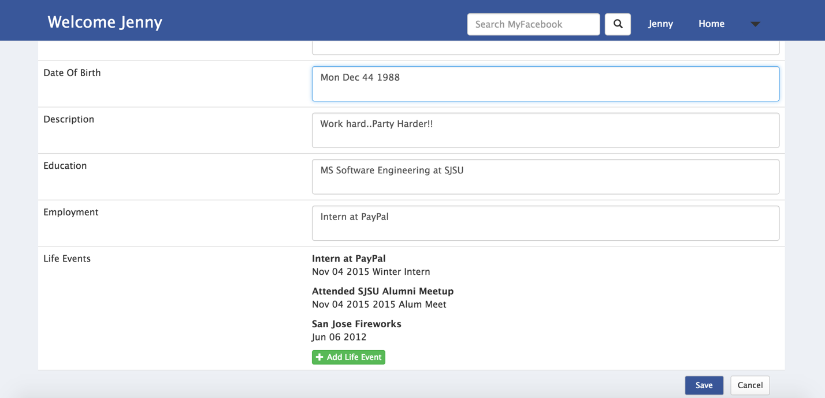

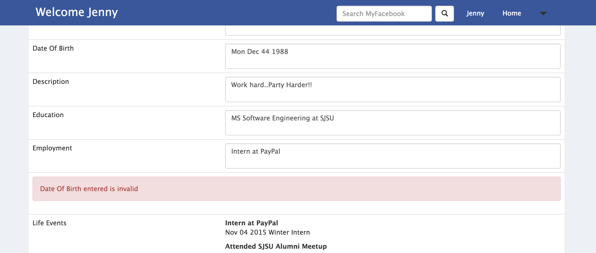

* + - Add Life event: Add new life events with title, description and event date. Event title and time fields are required and event date must be valid

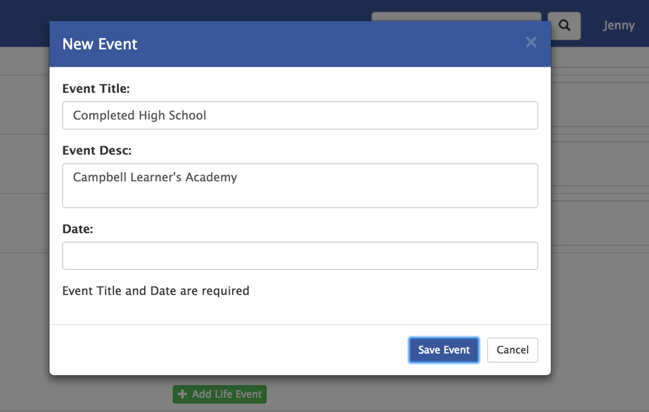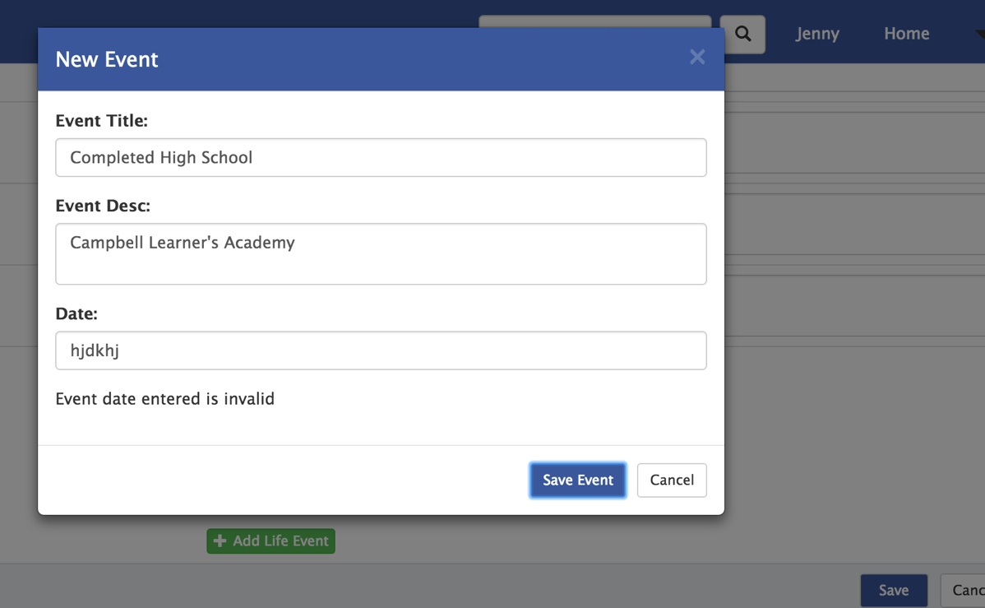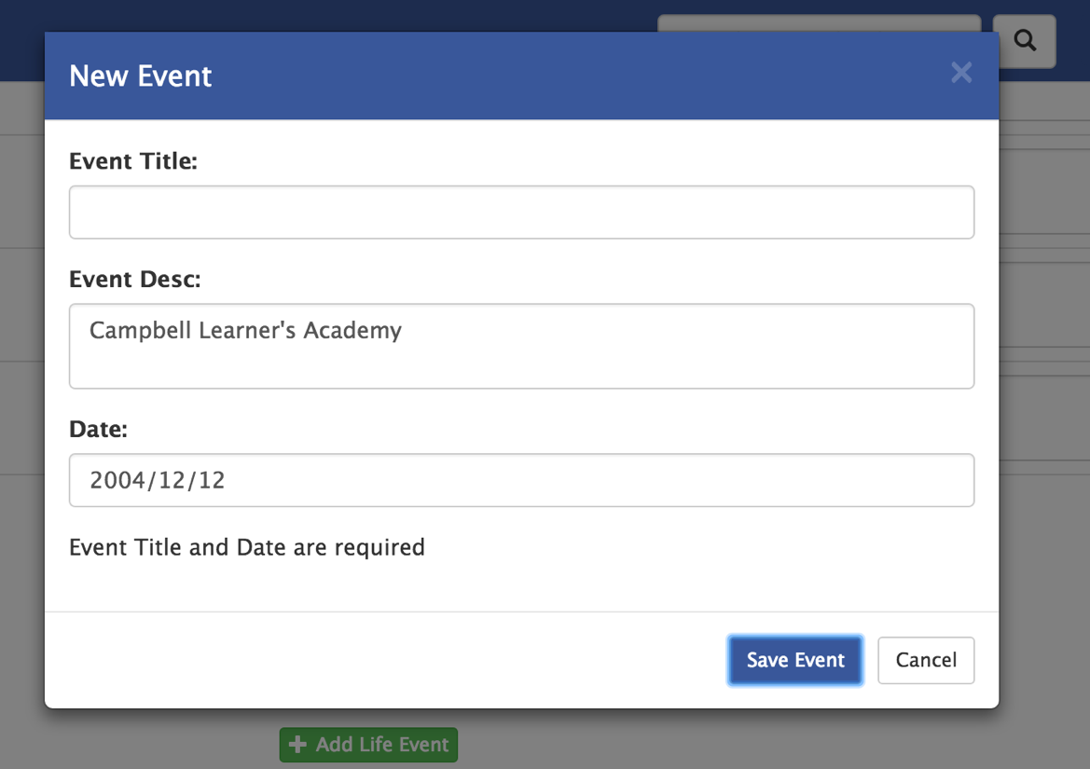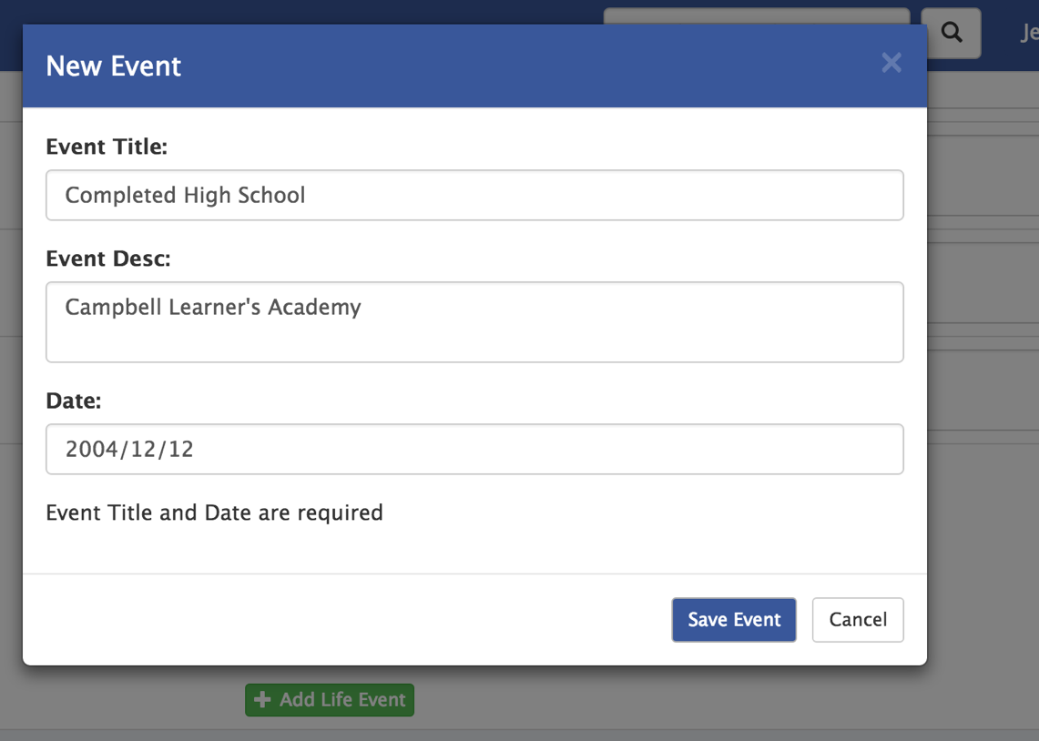

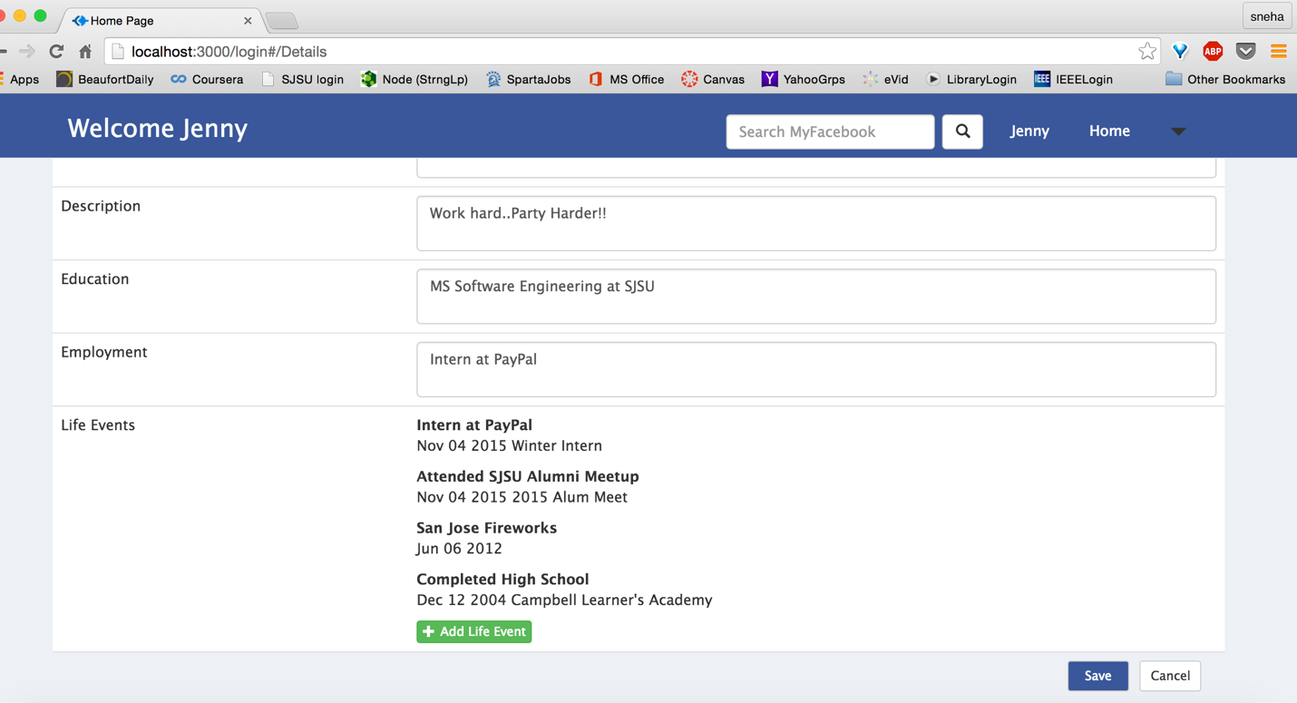

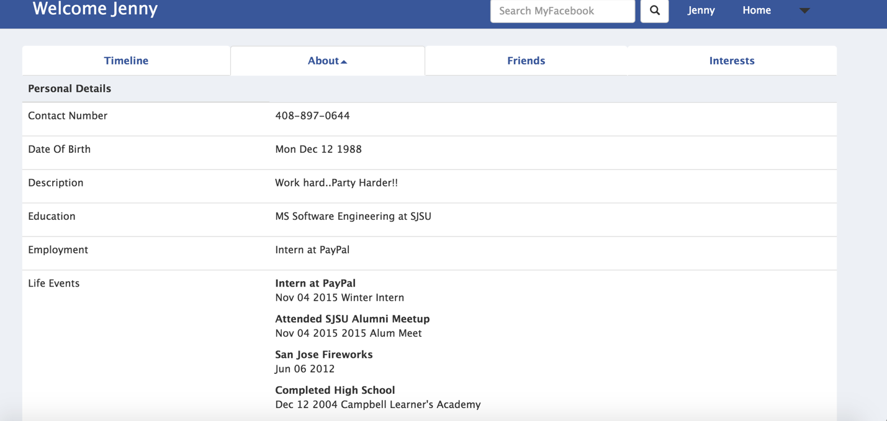

* + Friends
    - Current friends
      * View Current friend list, friends whose requests user has accepted and vice versa

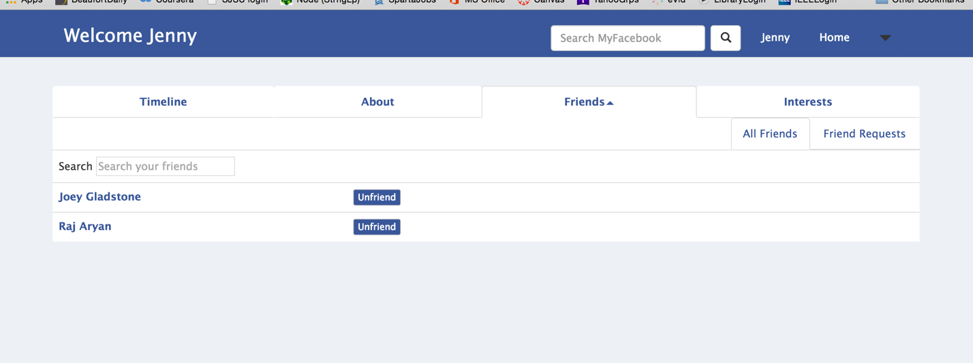

* + - * Unfriend option to remove user as friend, using the unfriend option (Unfriend Raj Aryan from above list and accepting Jesse Roger’s request)

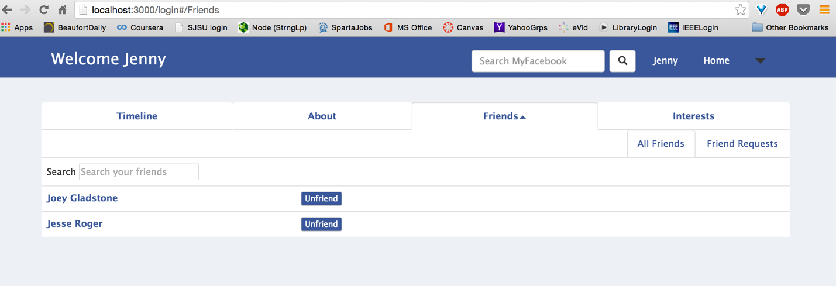

* + - * Search box for list to search from a long list
    - Friend Requests

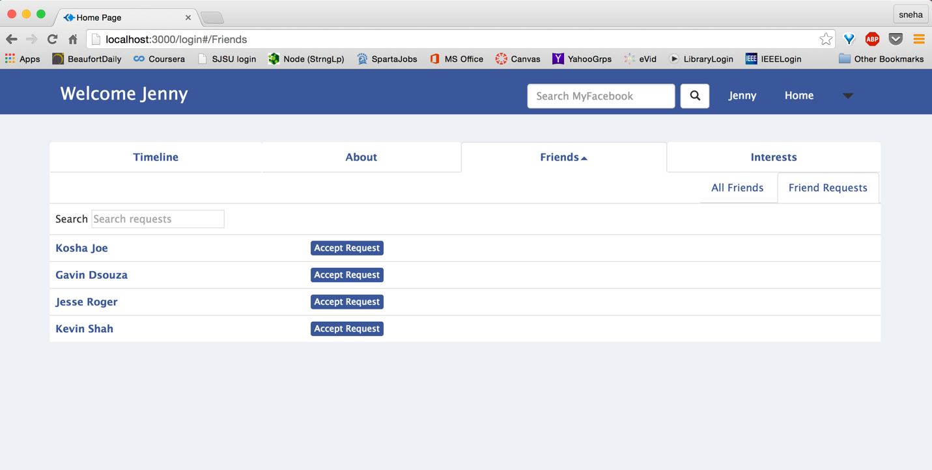

* + - * Accept request: View list of requests from other users (Accepting Jesse Roger’s request)



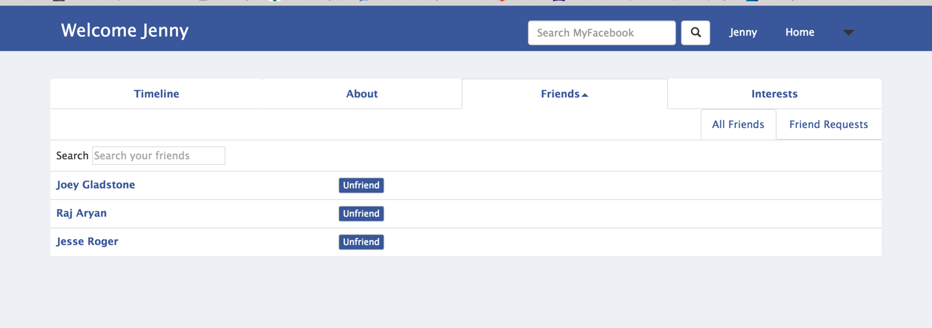

* + - * Search box for list to search from a long list

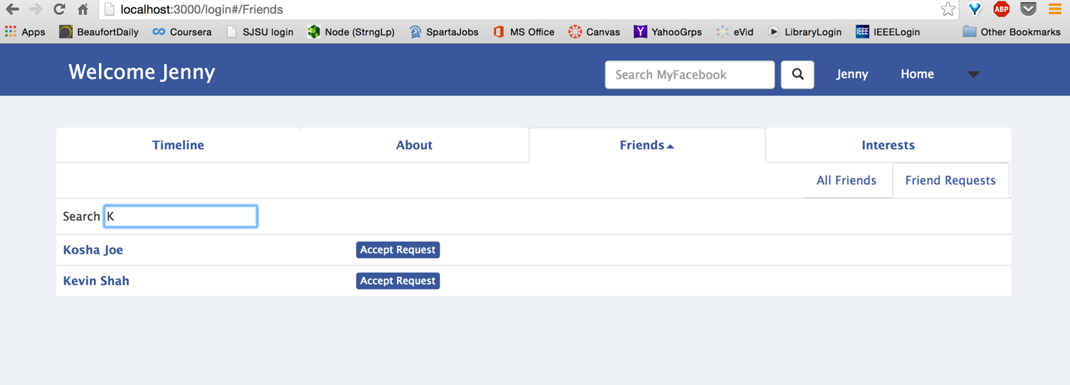

* + Interest
    - View Interests selected earlier

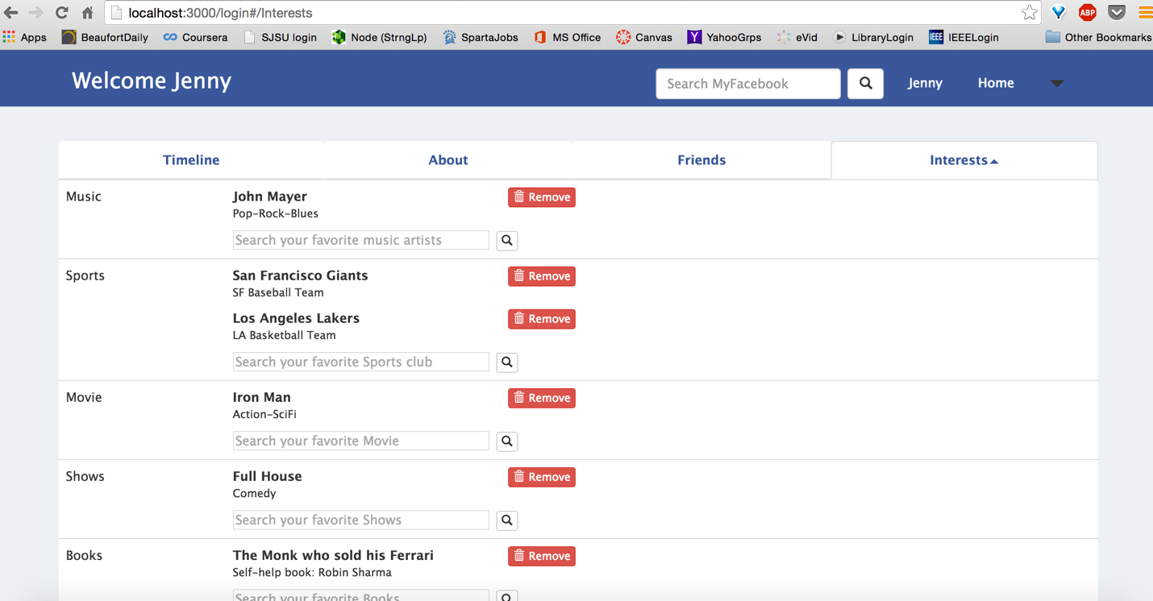

* + - Search interest by type: Search bar each interest added separately

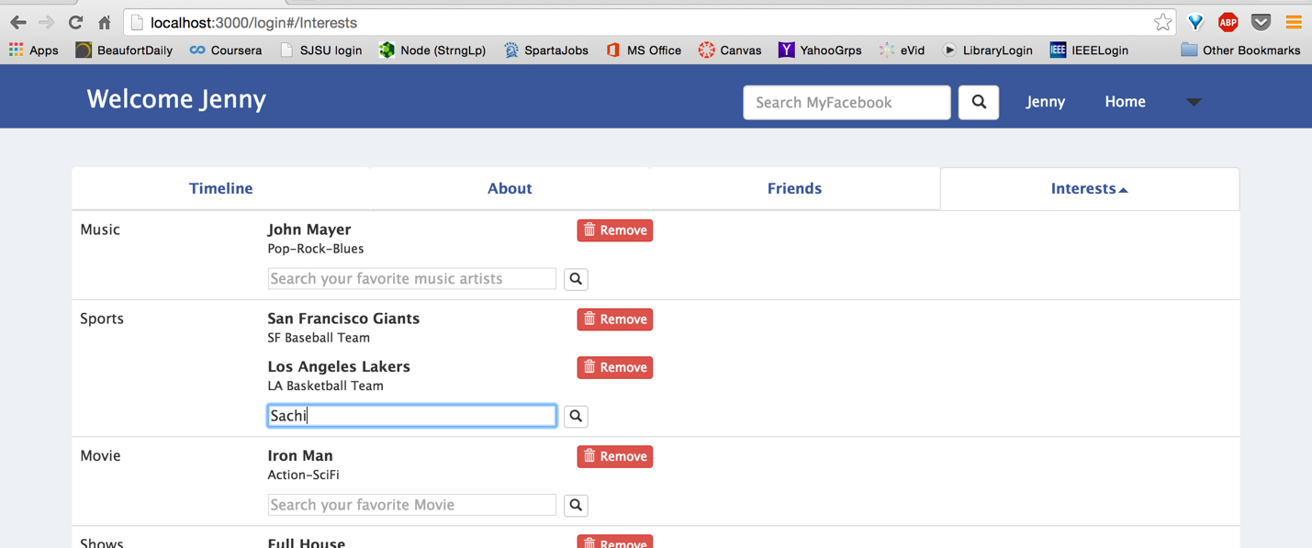

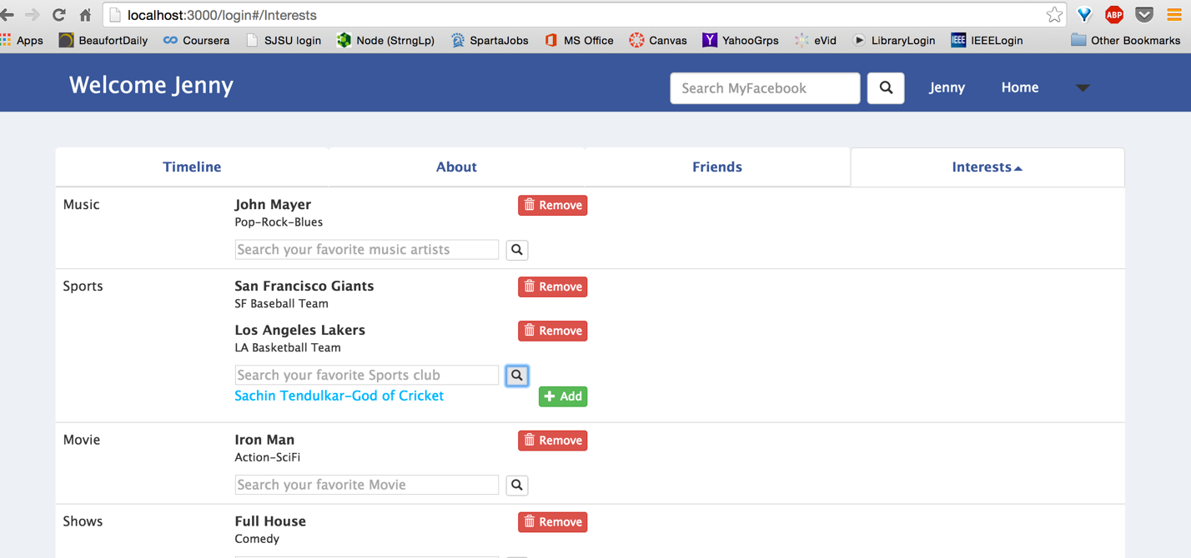

* + - Add Interest: Add interest from result

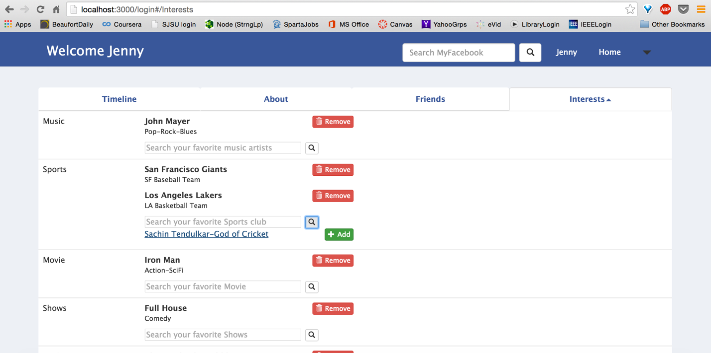

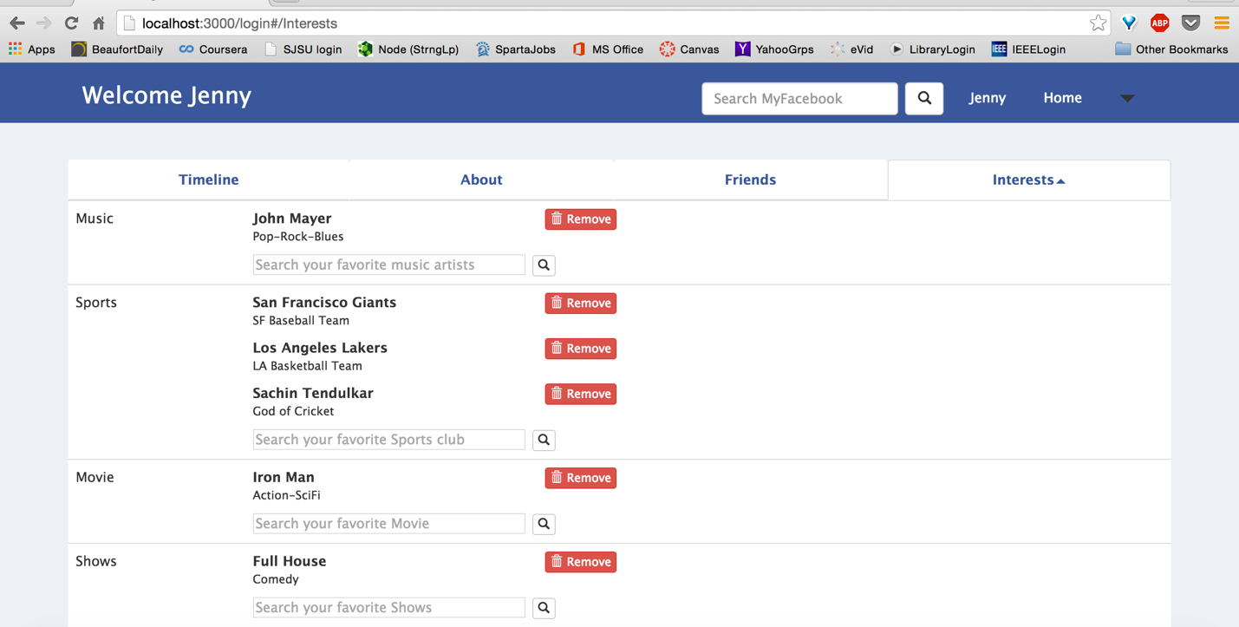

* + - Remove interest: Remove interest previously selected (Removing John Mayer from Music)

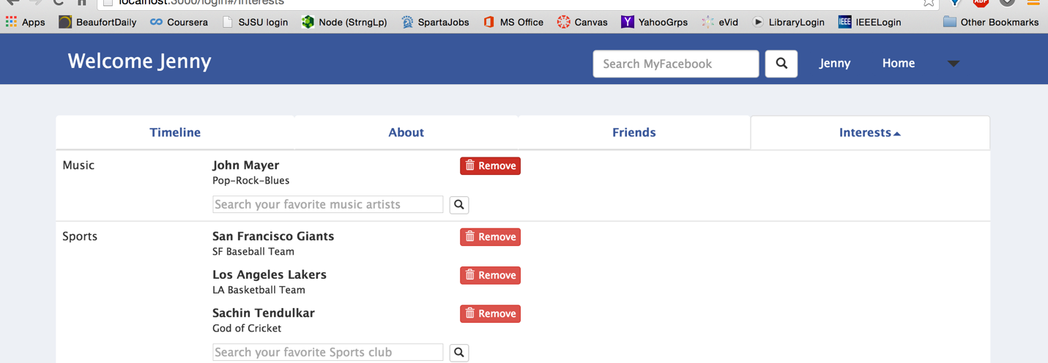

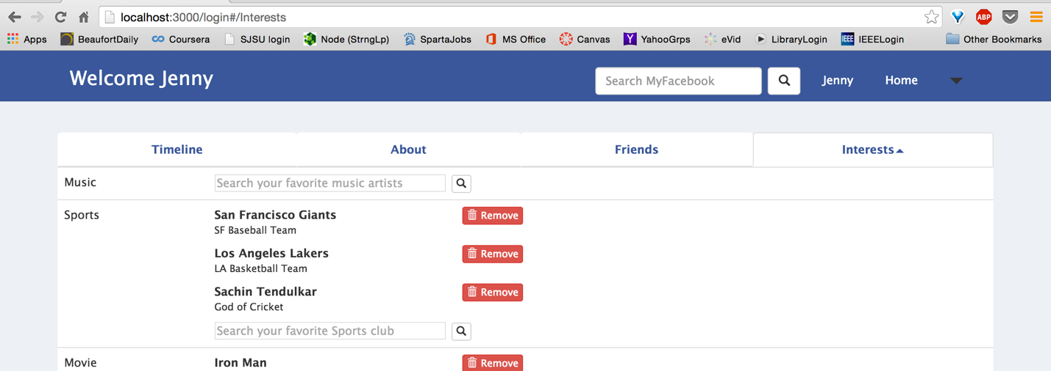

One can access user Home Page by Clicking his name from the nav-bar right corner

* View News Feed
  + Click on Home option on top right corner

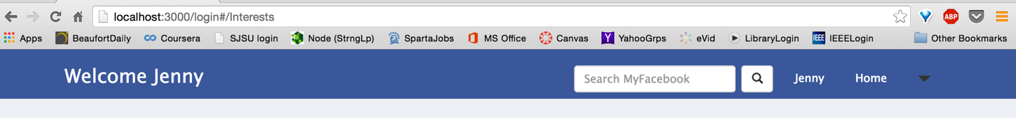

* + List of posts from friends and self (descending order of create time)

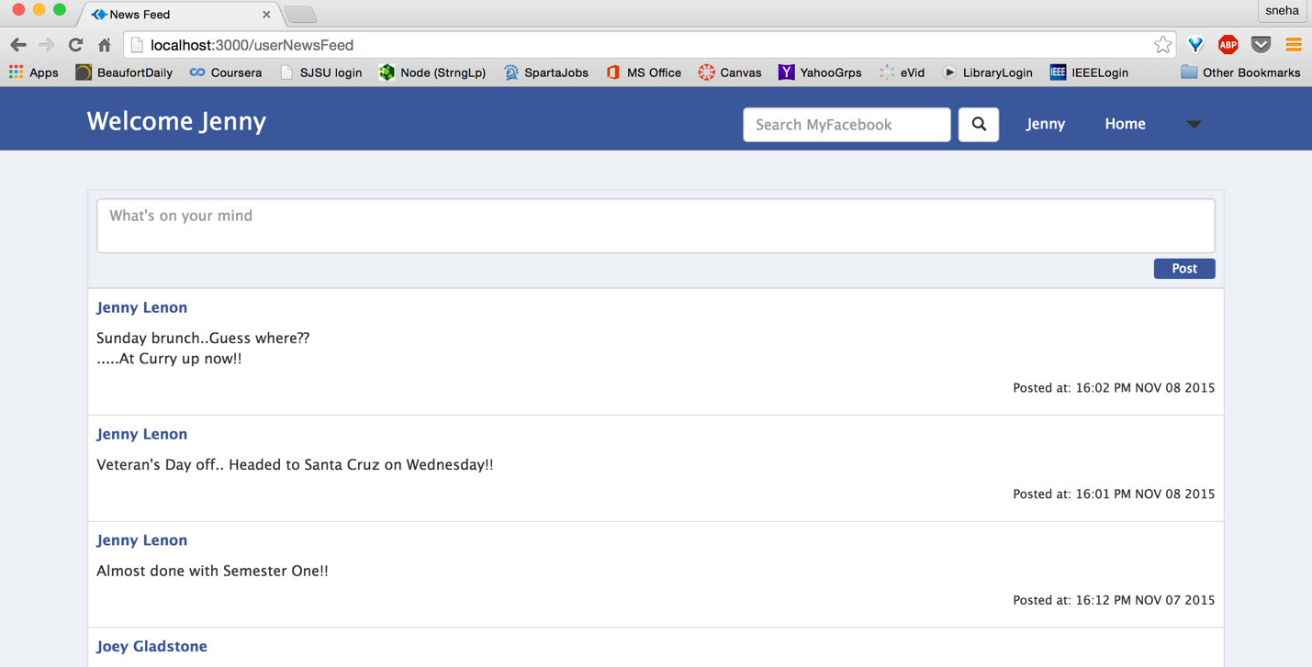

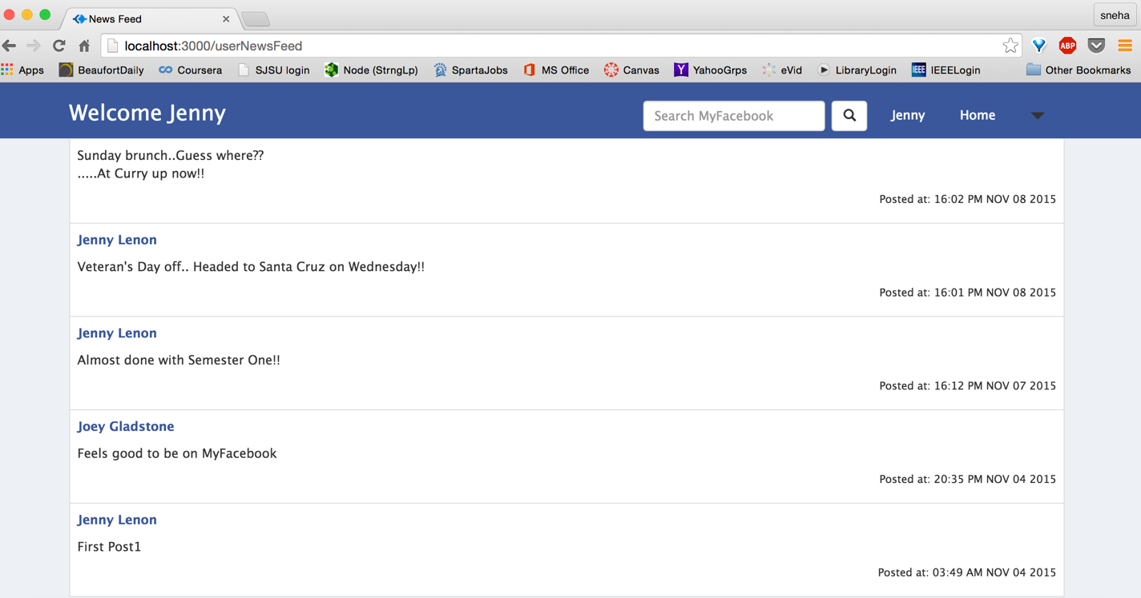

* + Can create new posts: Same as homepage create post functionality

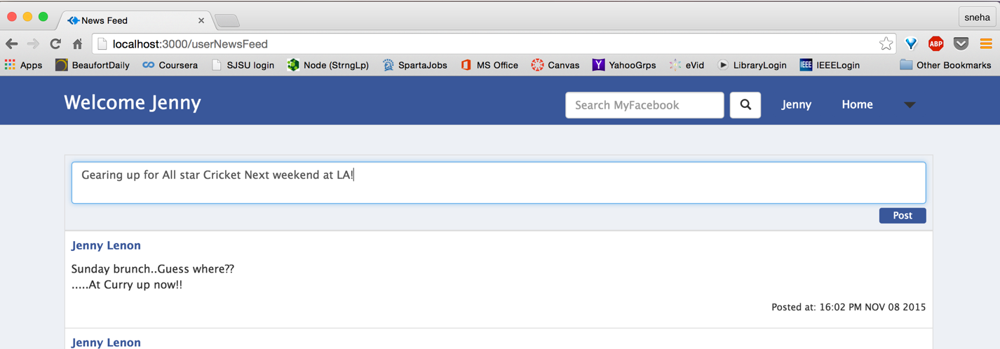

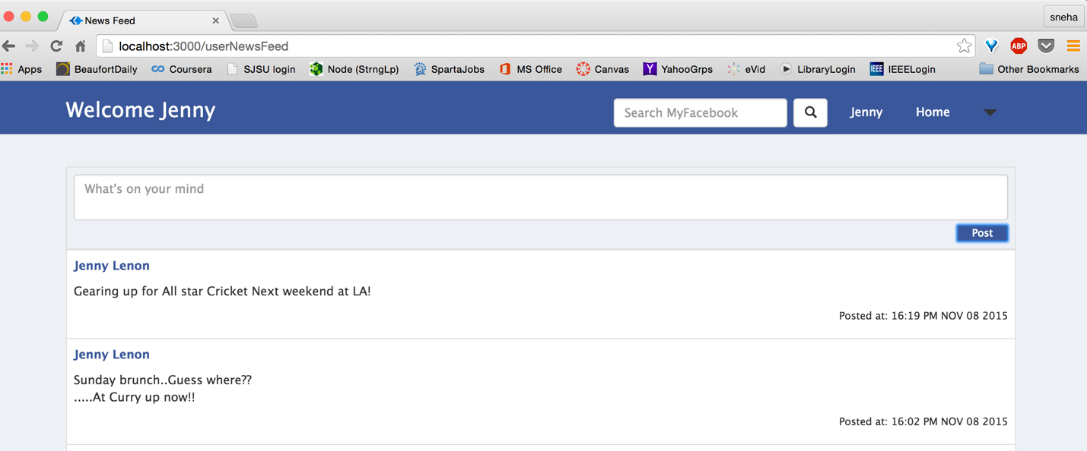

* Search Bar (In the Navigation Bar)
  + Search for Groups and Users: Enter name to searched

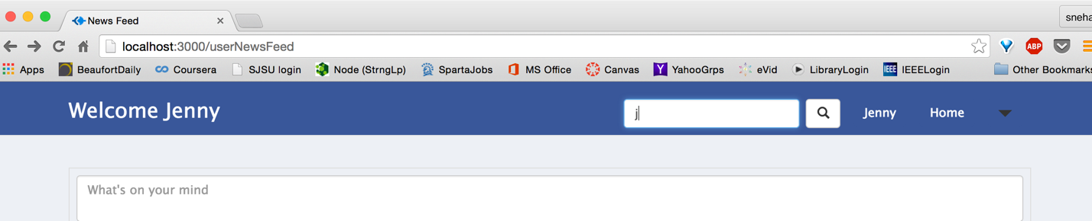

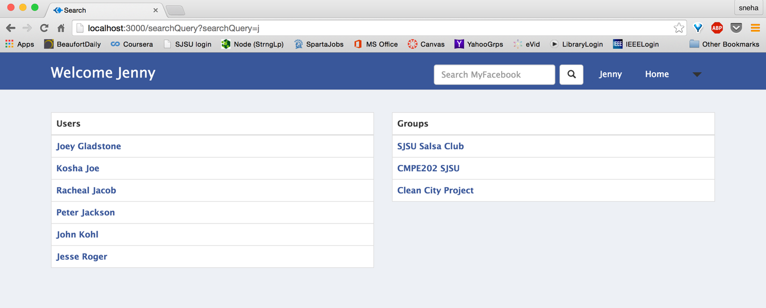

* + List of results displayed: Displays list of matching groups and Users. Check done against user firstname/lastname and group name/description

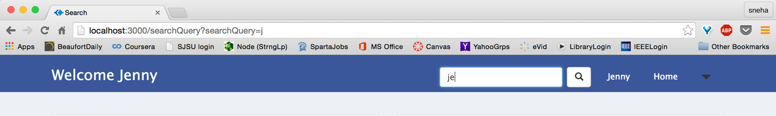

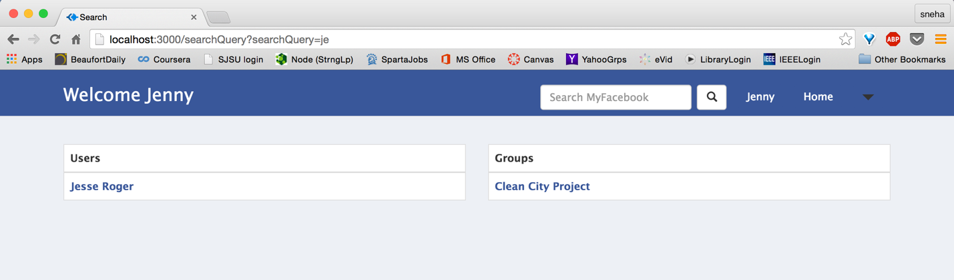

* + Click on user/group to view respective profile

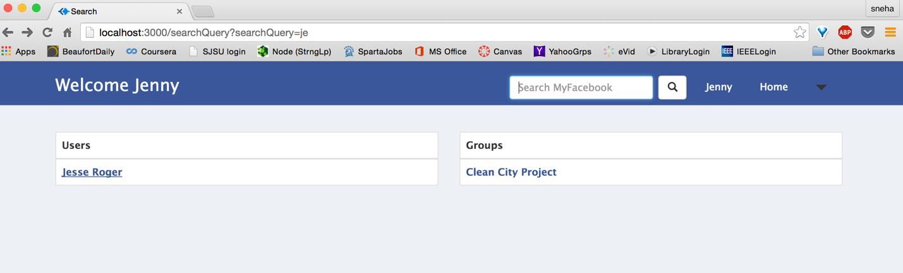

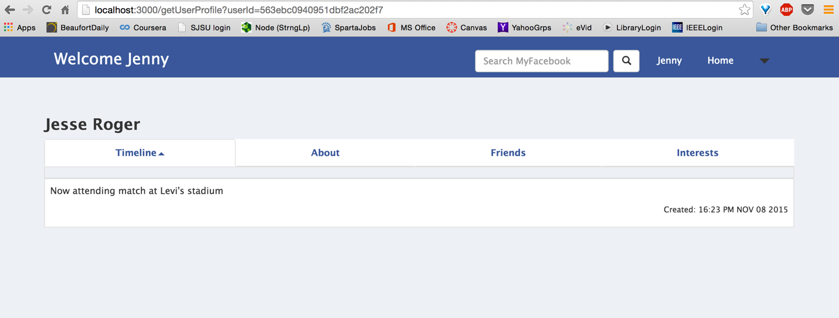

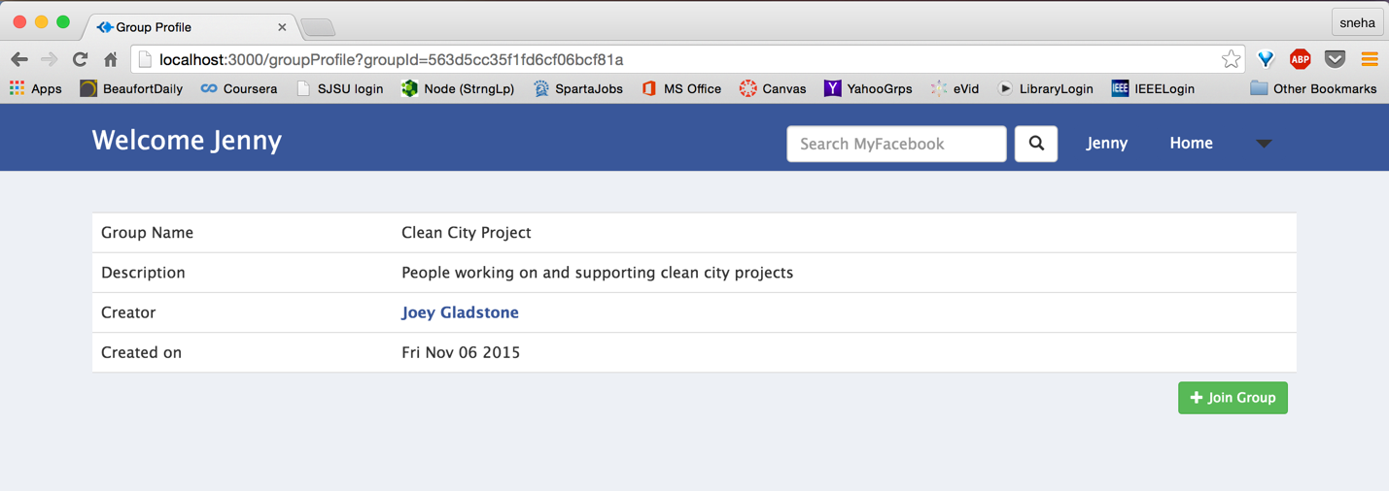

* Groups:

(Access groups page from nav-bar dropdown menu)

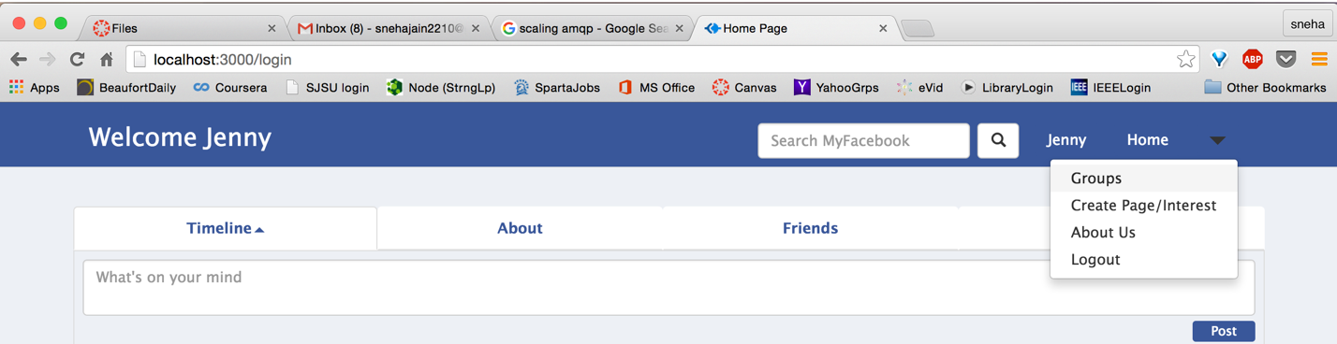

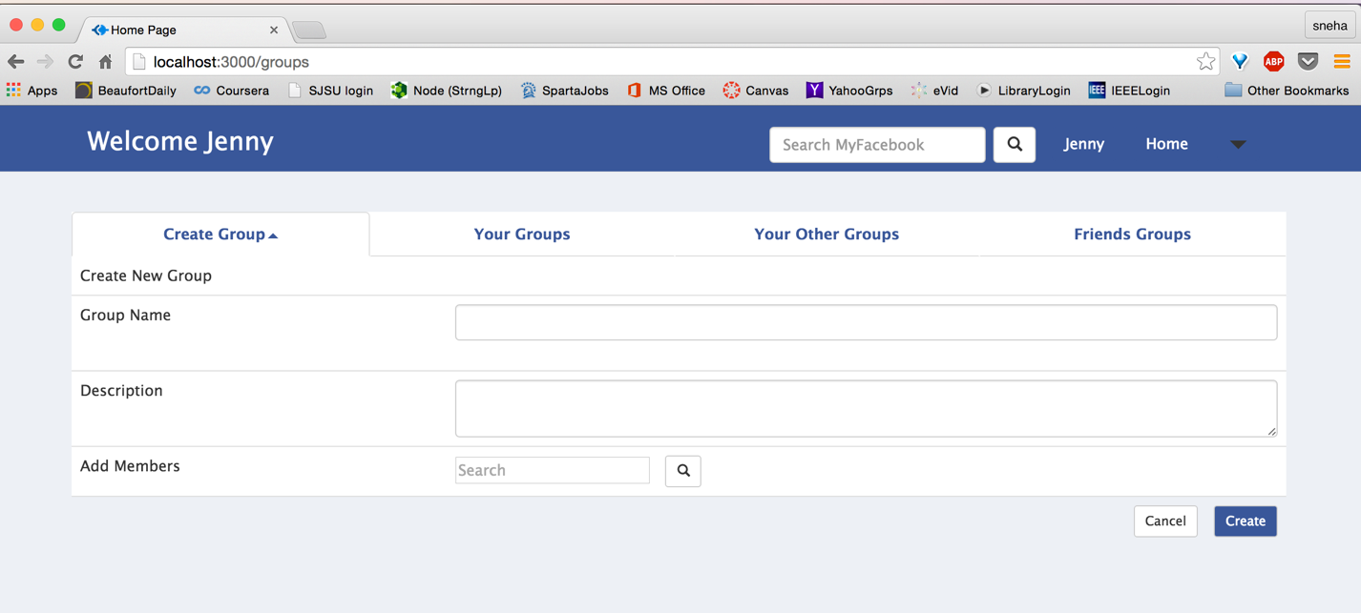

Has four navigation tabs namely:

* + Create Group
    - User can create a new group

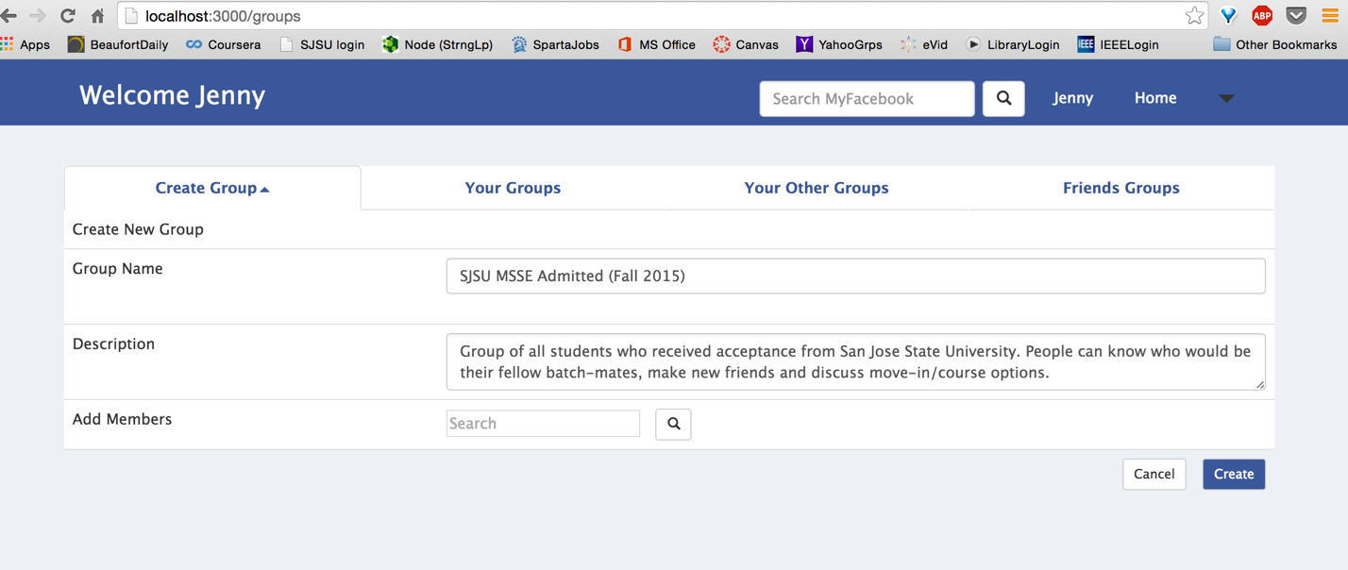

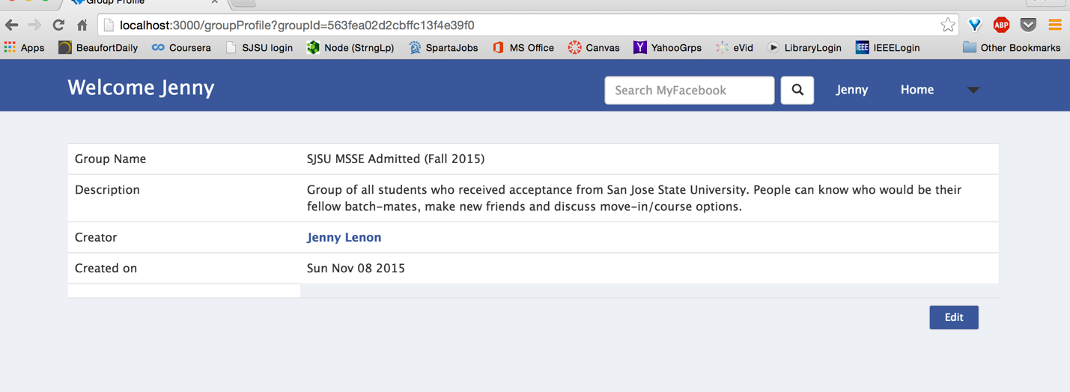

* + - Group name mandatory

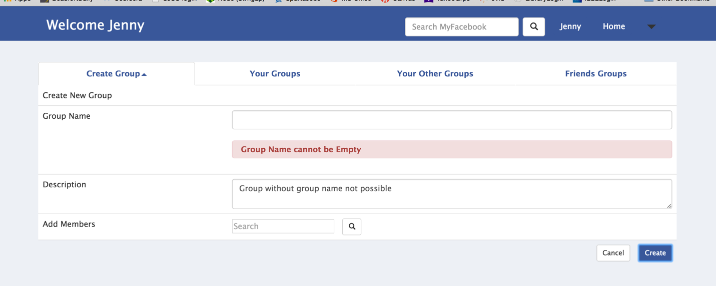

* + - Add members to groups using search bar in create group

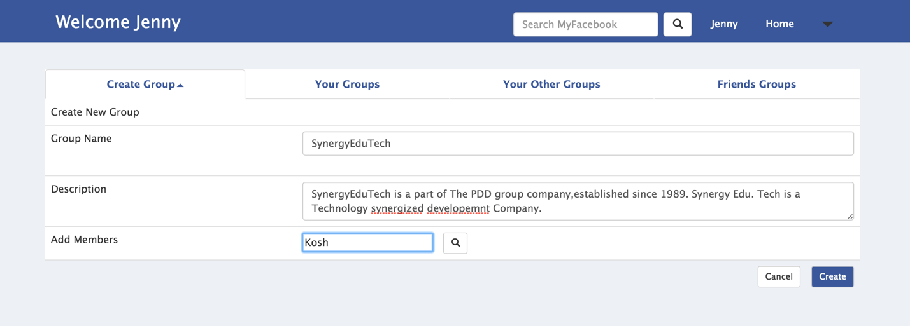

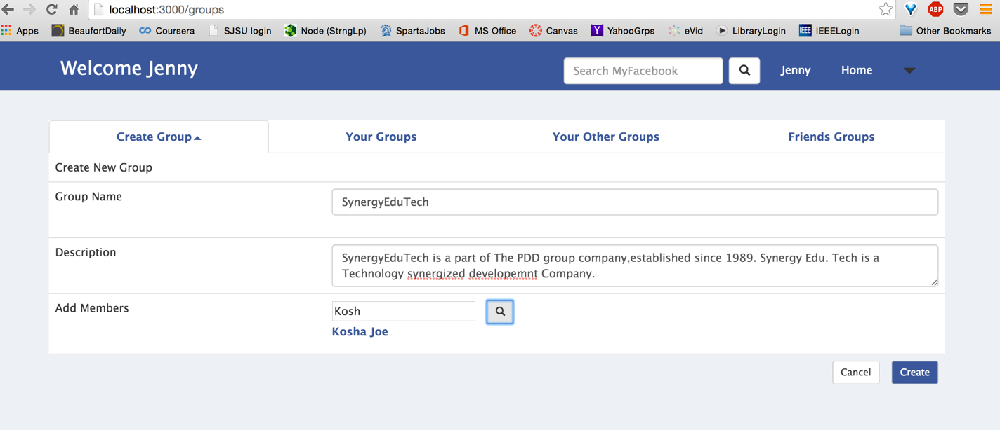

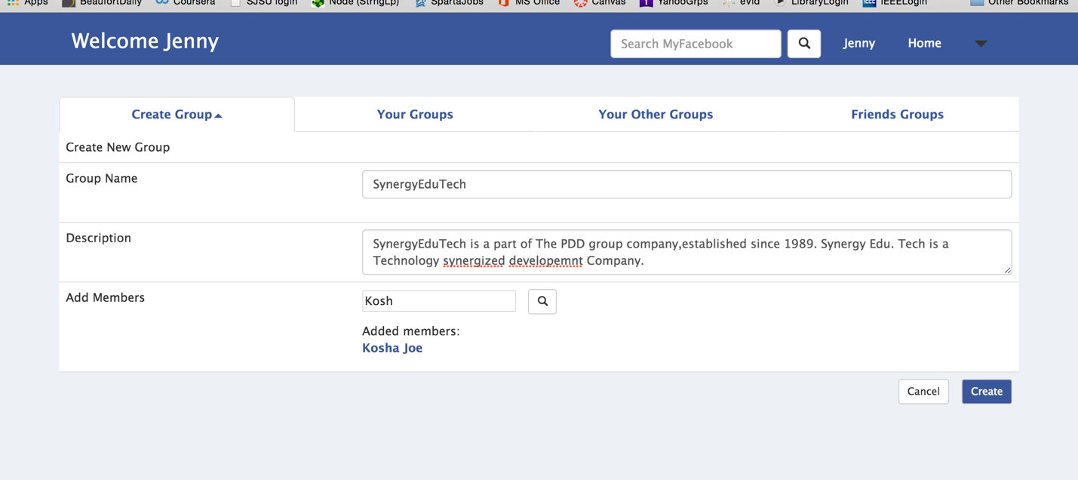

* + Your Groups
    - View list of groups created by user himself

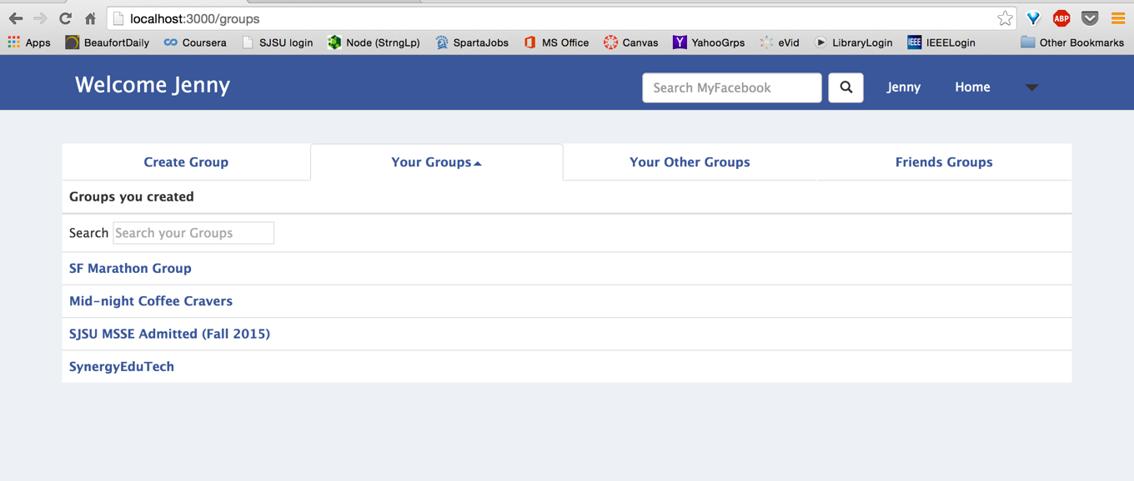

* + - Go to group profile page by clicking on group-name

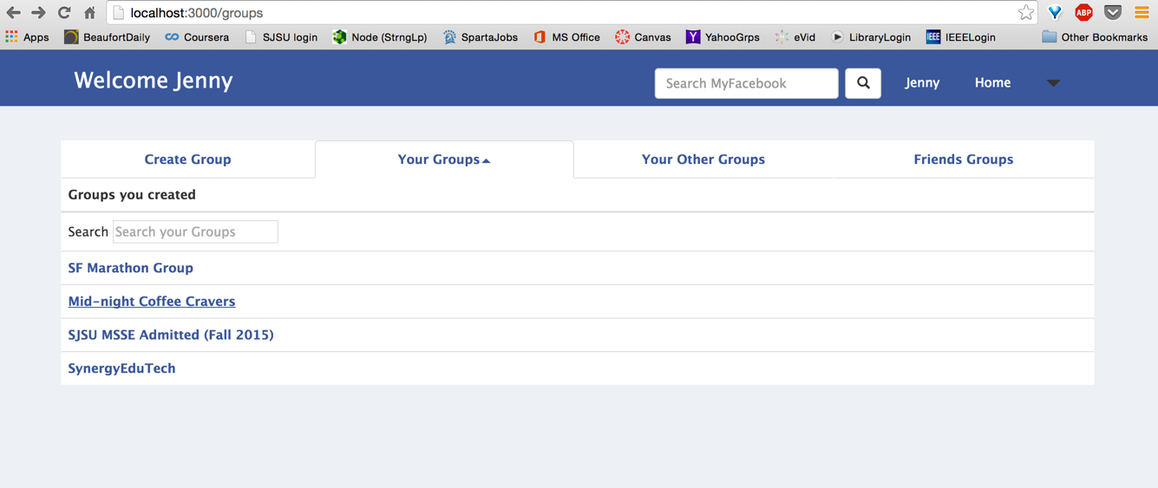

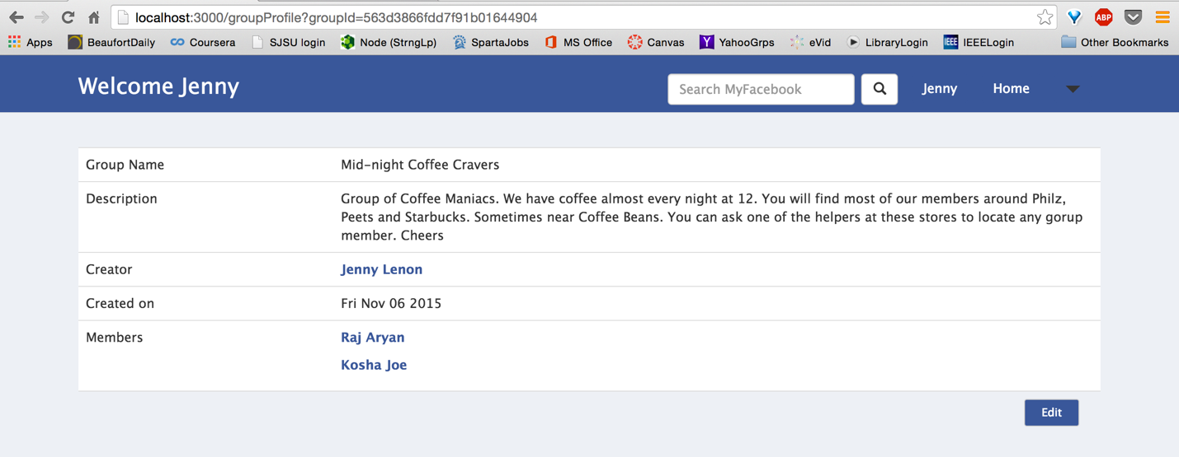

* + Your Other groups
    - View list of groups user is a member of

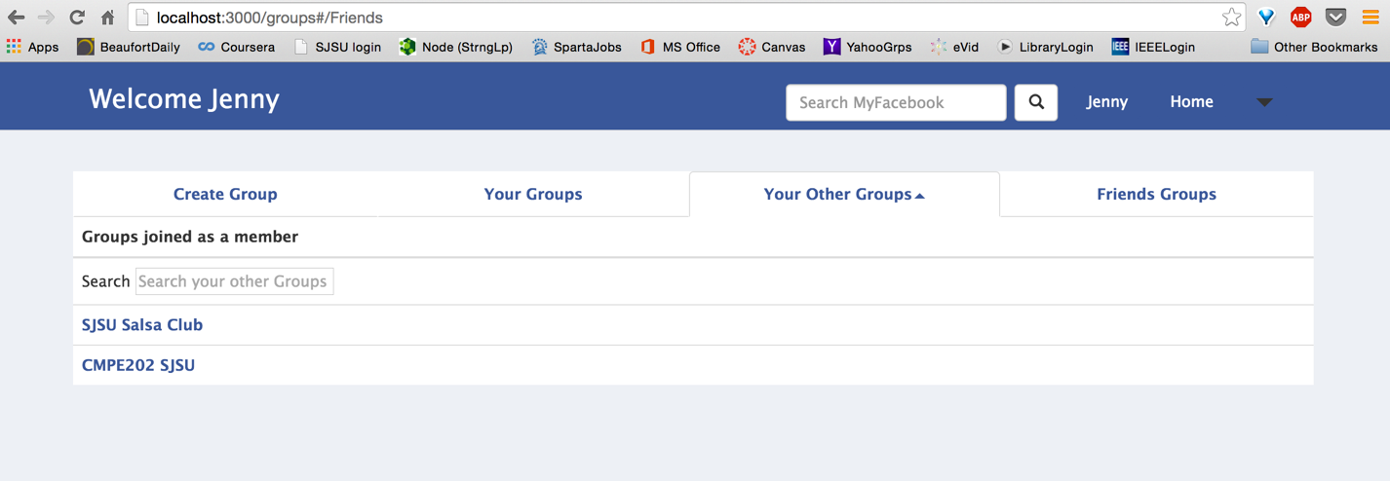

* + - Go to group profile page by clicking on group-name (Same as viewing your group)

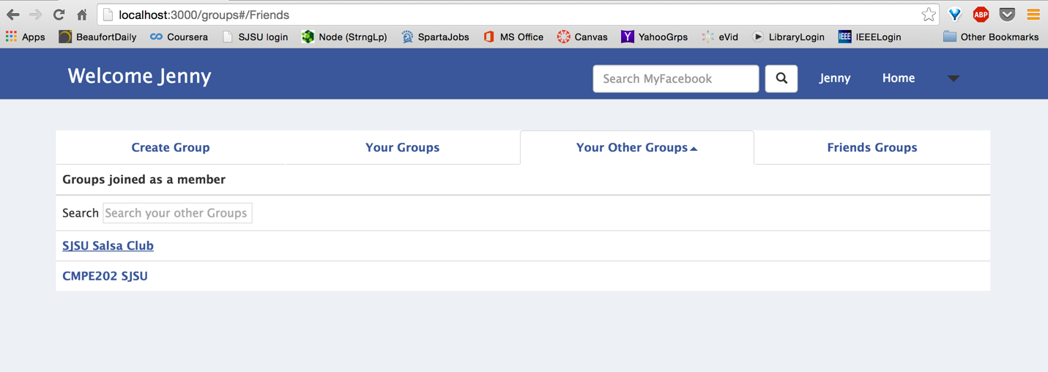

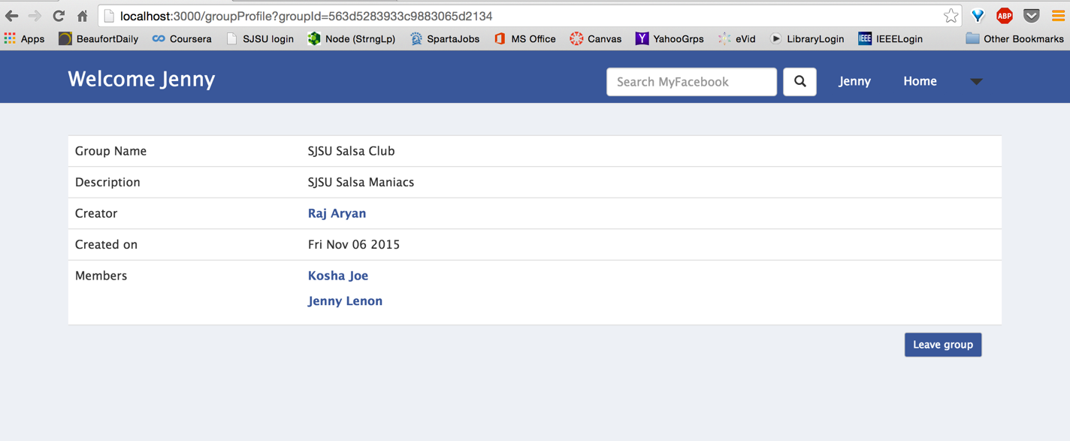

* + Friends Groups (List of groups that user’s friends have created or are a member of and user is not a member of. Groups listed in descending order of popularity. Groups with more members will be listed above groups with lesser members)
    - View list groups user is not a part of

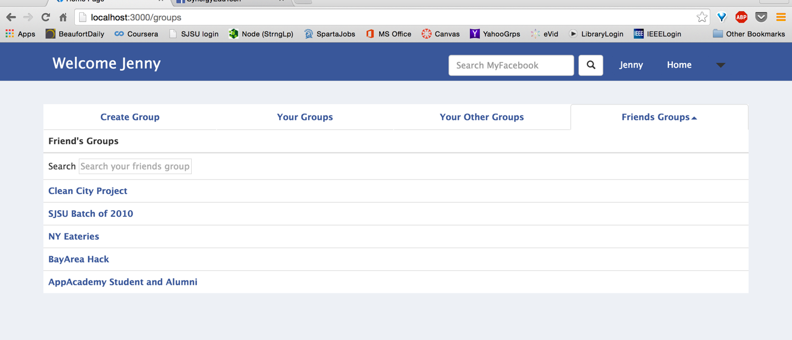

* + - Go to group profile page by clicking on group-name (Similar as above)
    - Search box to search from long list

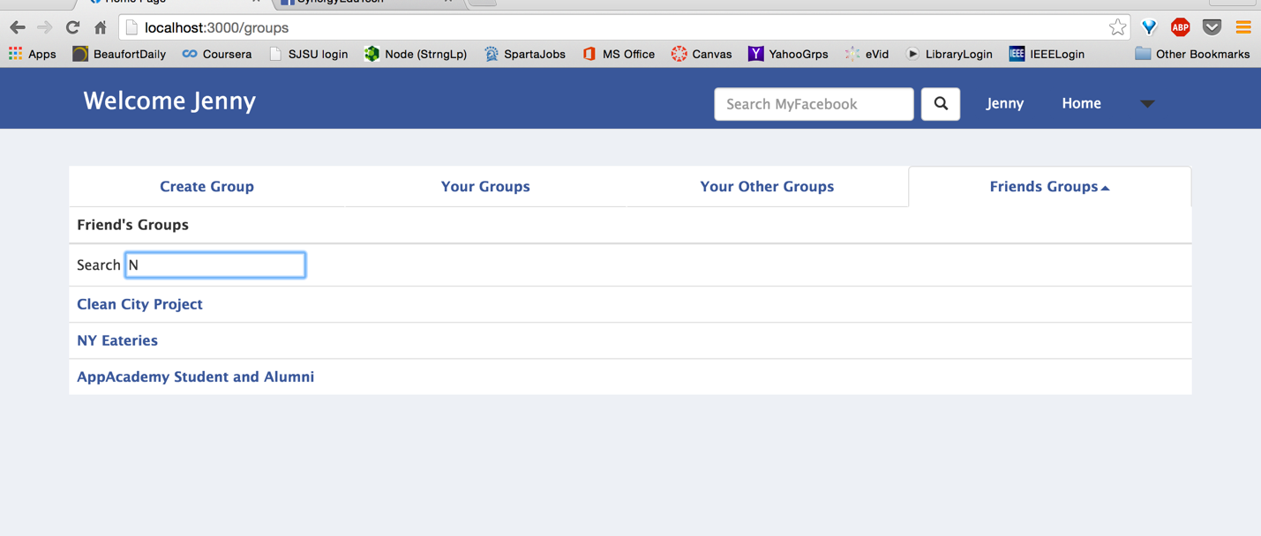

* Group Profile
  + View: Different views implemented
    - Creator of the group will have edit option



* + - Member of the group will have Leave Group option



* + - Outsider will have Join group option (Outsider can’t view Members of a group, only group-name, description and creator)

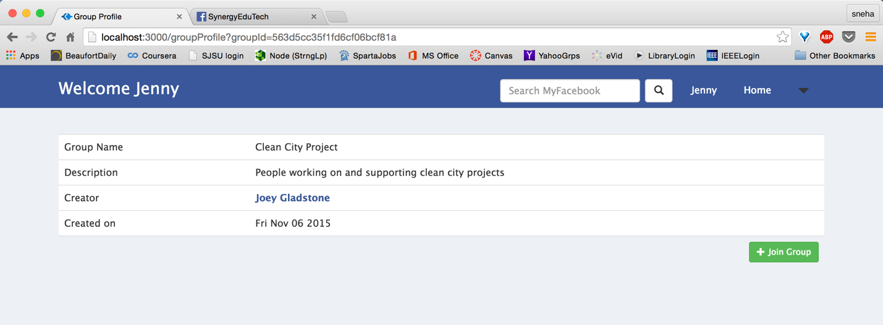

* + Join a group



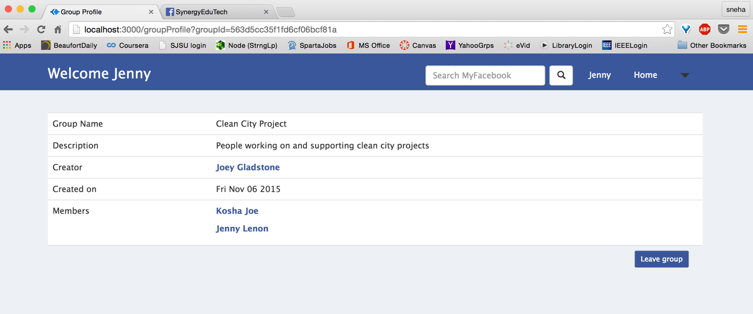

* + Edit
    - Add/Delete Members (Removing Joey from group, adding Jesse)

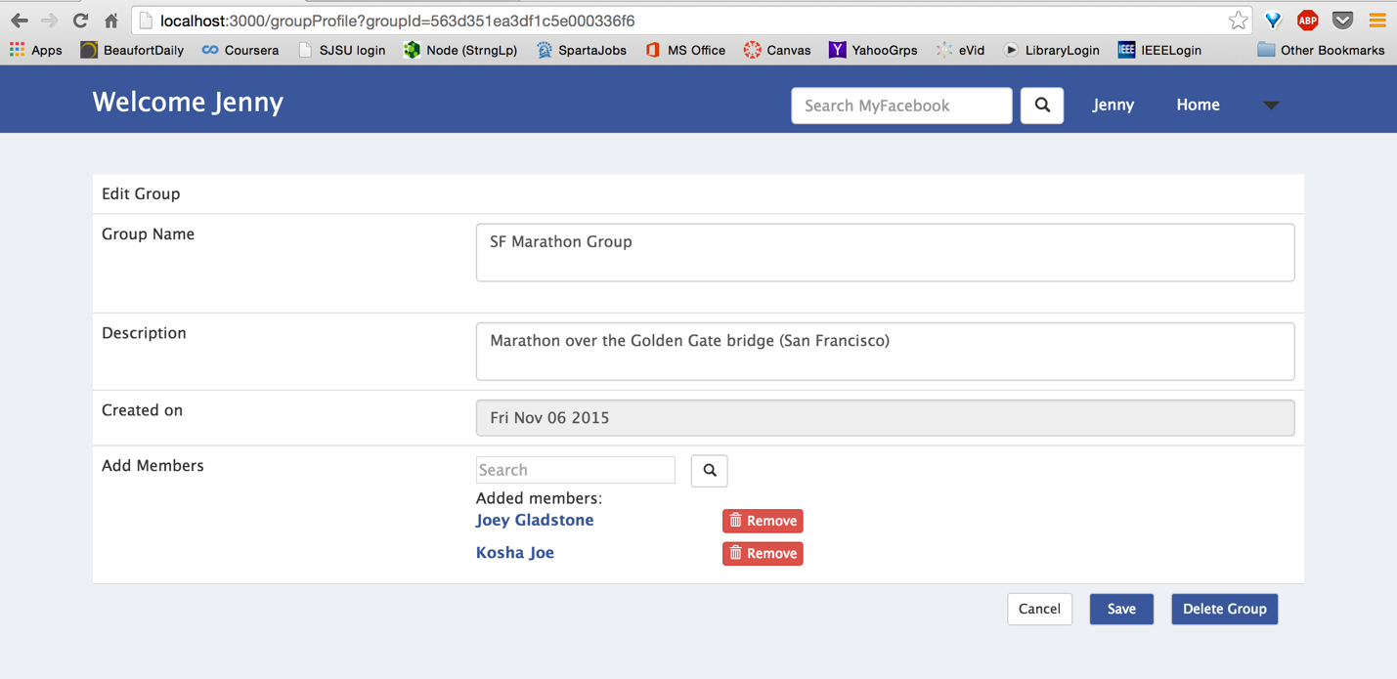

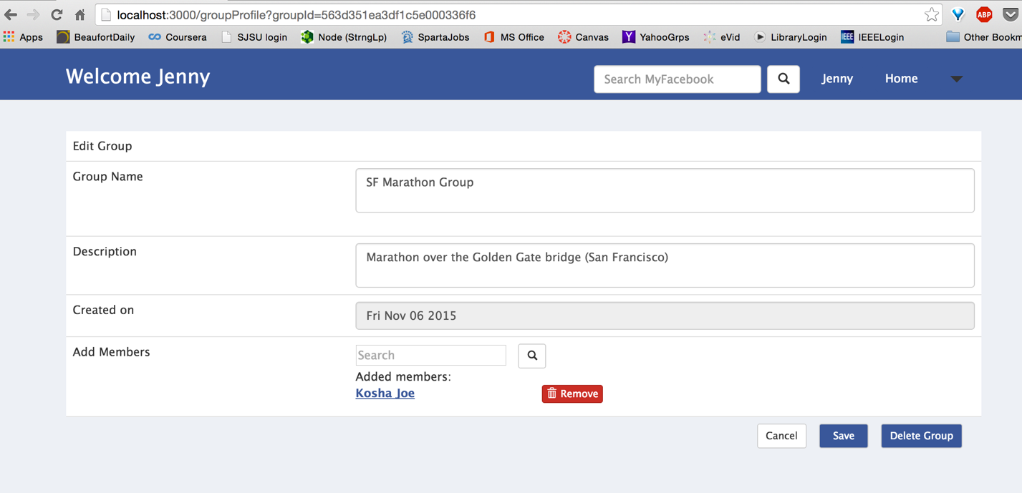

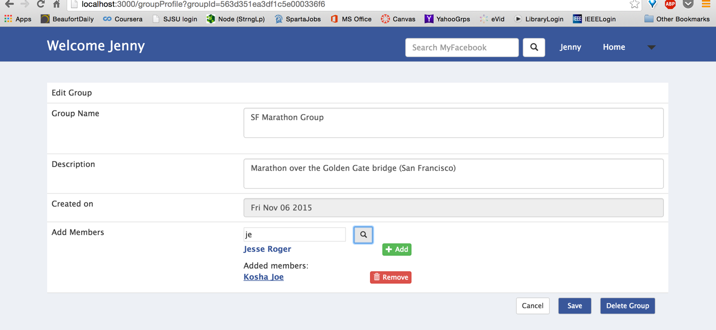

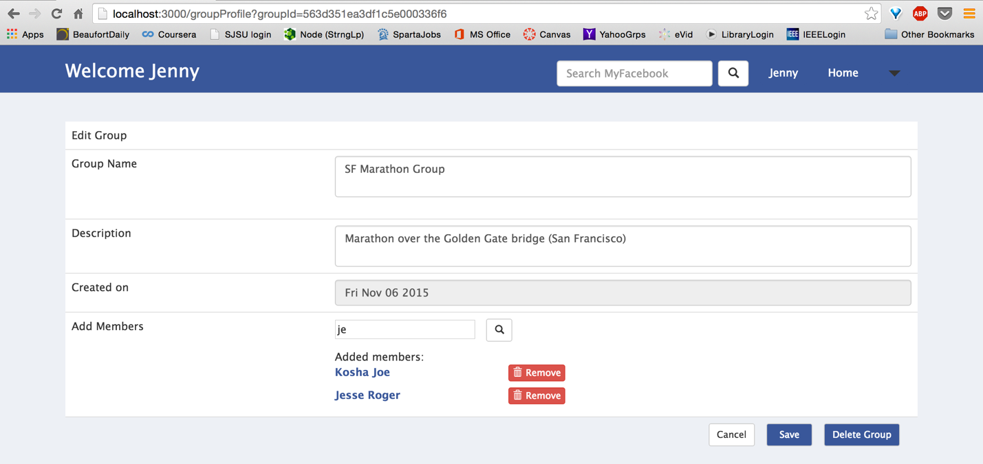

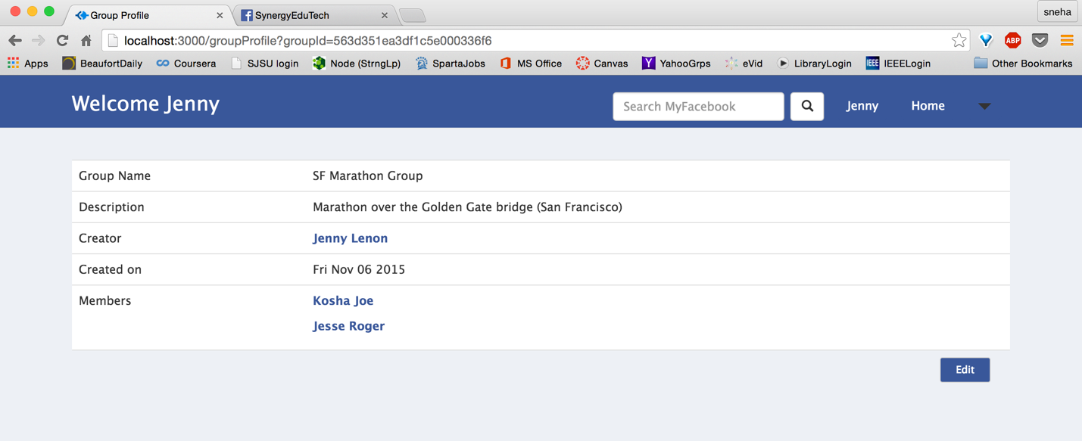

* + - Group name cannot be null validation

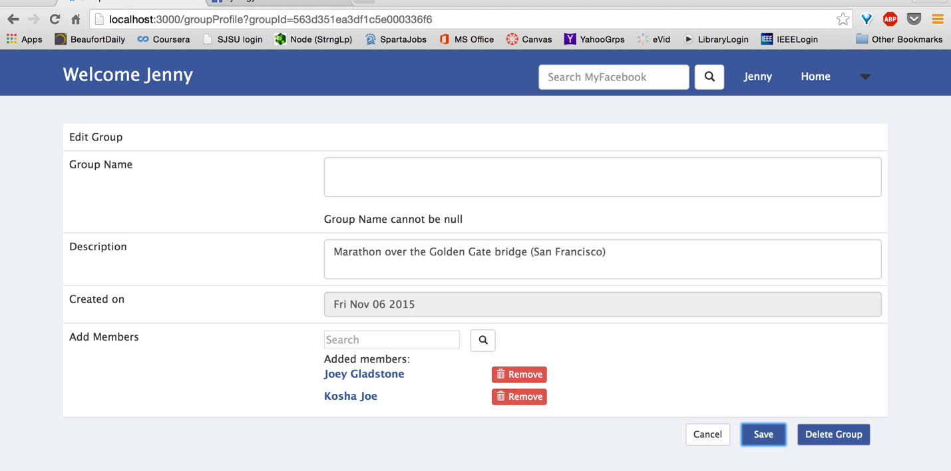

* + Leave a group

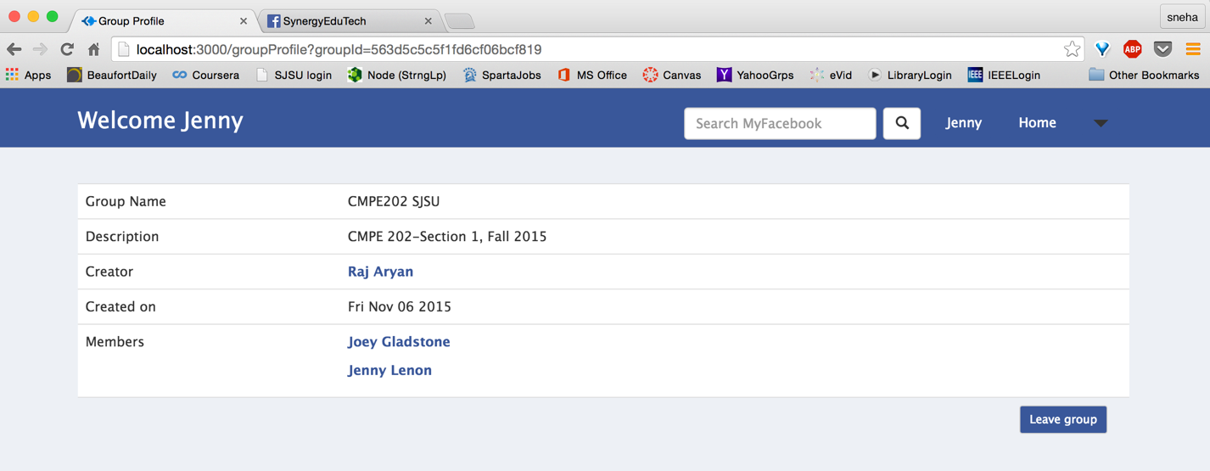

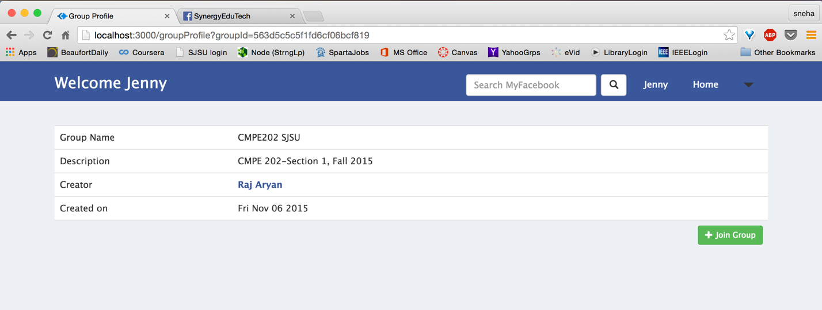

* + Delete a group (Only for creator of the group)

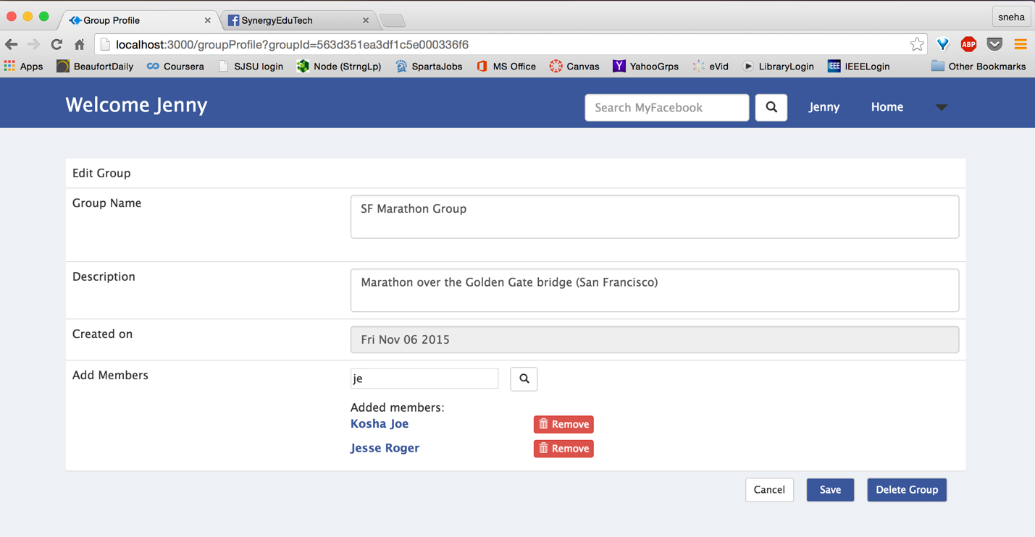

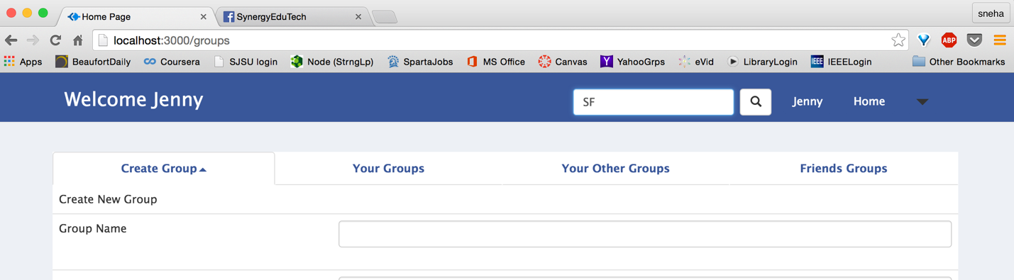

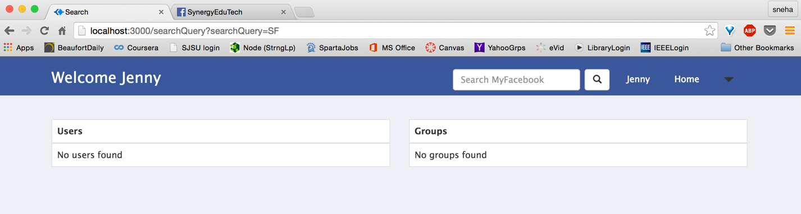

* Friend profile:
  + Timeline: Views posts from friend

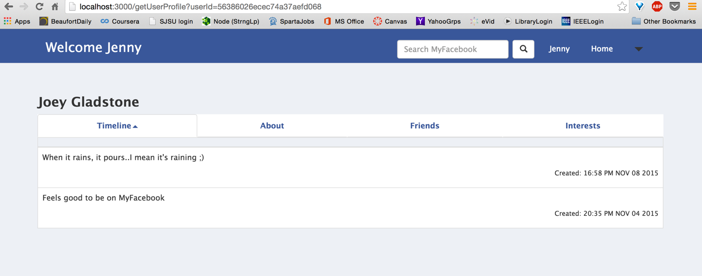

* + About: View friend’s profile details

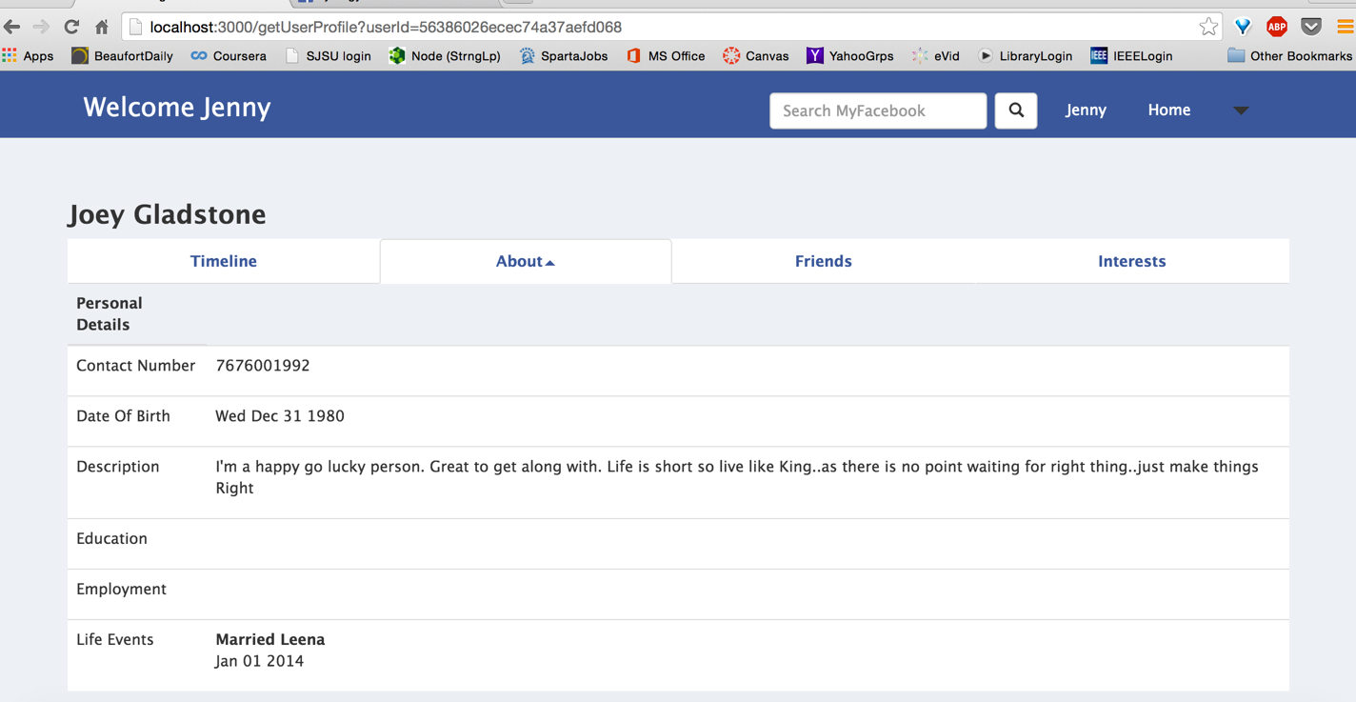

* + Friends: View friend’s friends

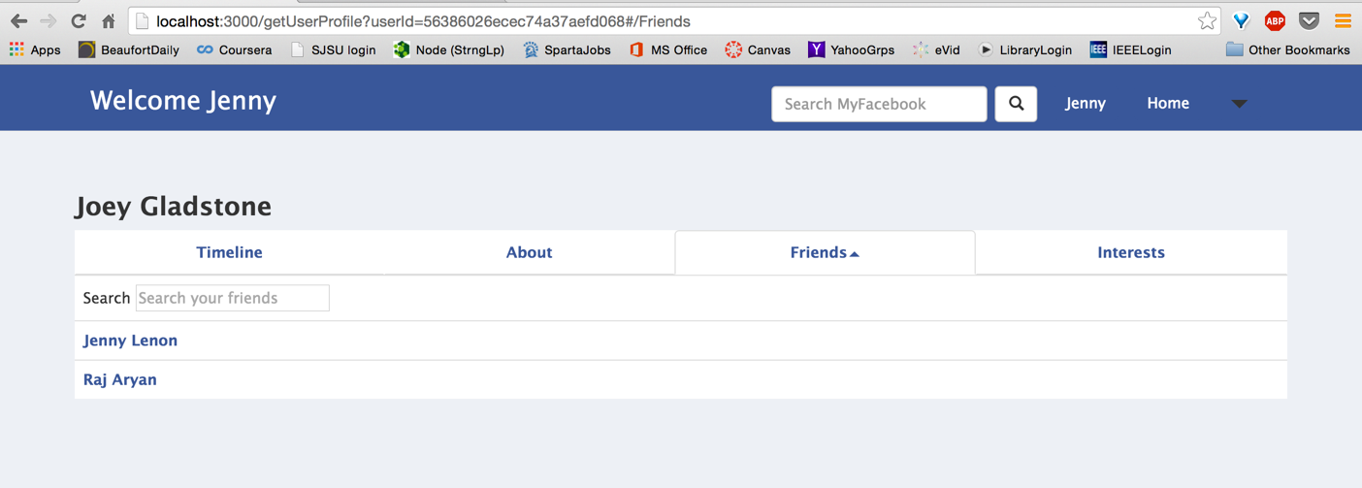

* + Interests: View friend’s interests

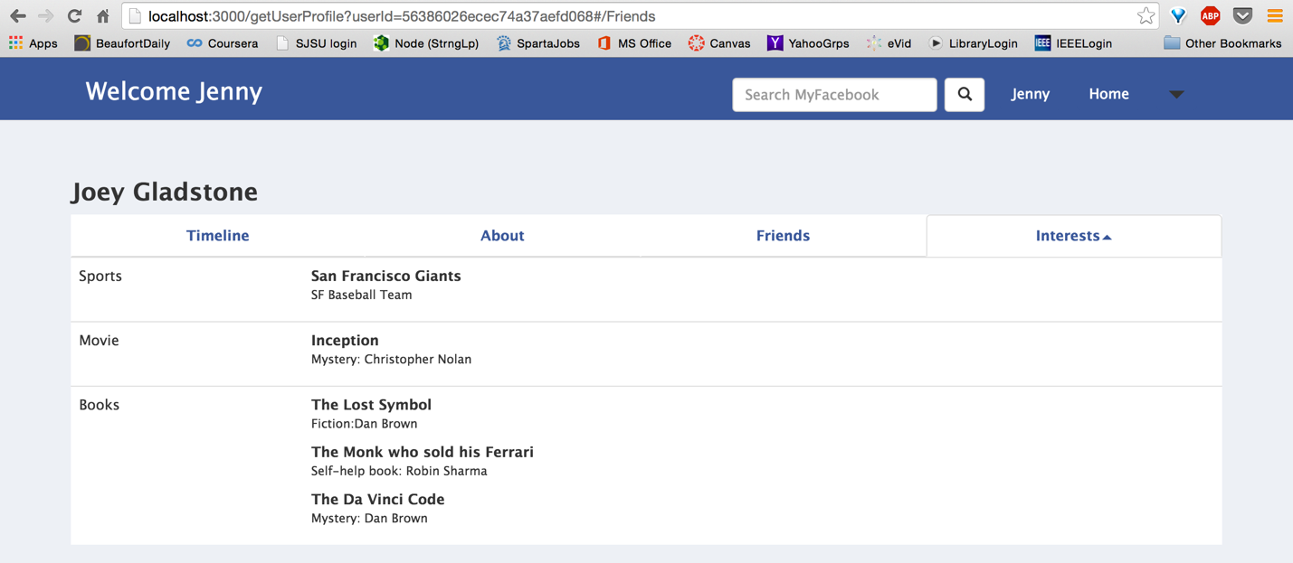

* User friend requests:
  + Send friend request

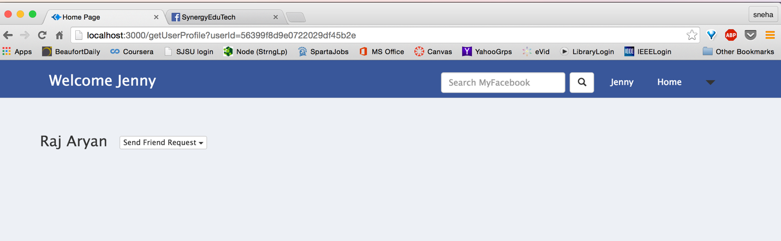

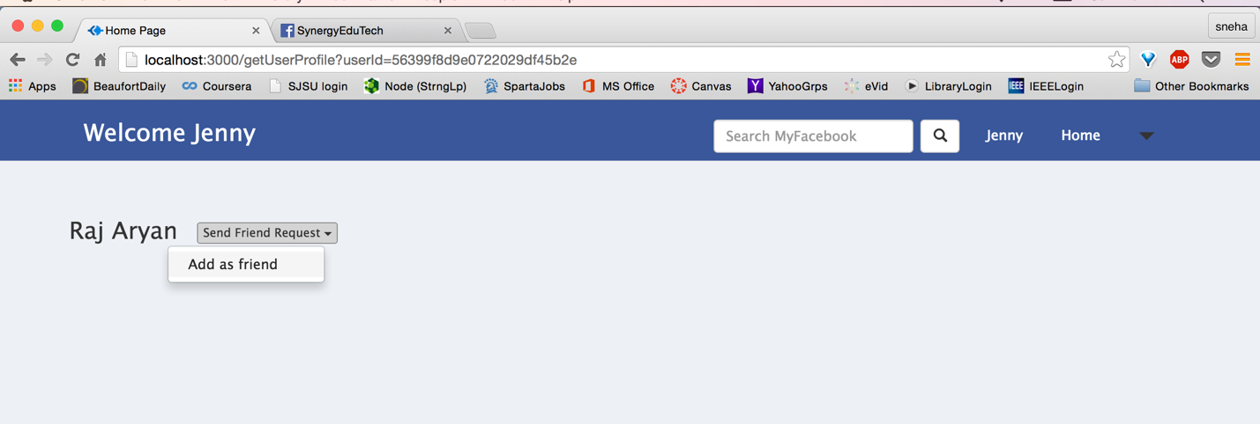

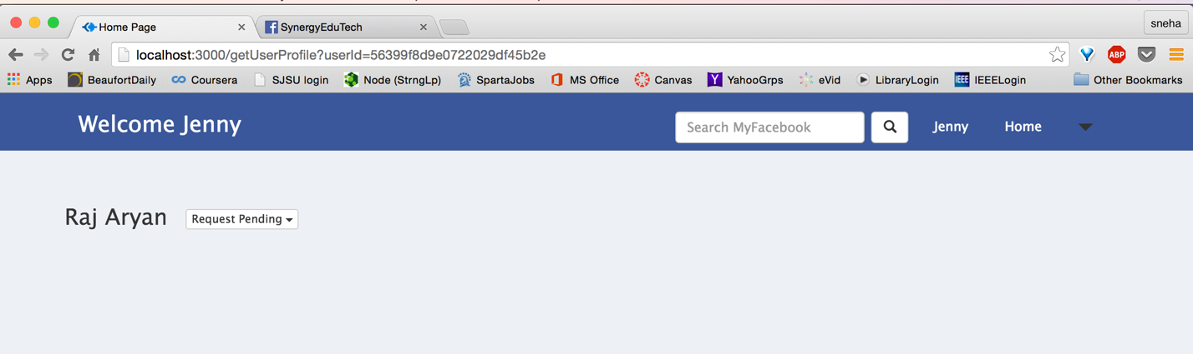

* + Respond to friend request
    - Accept friend request

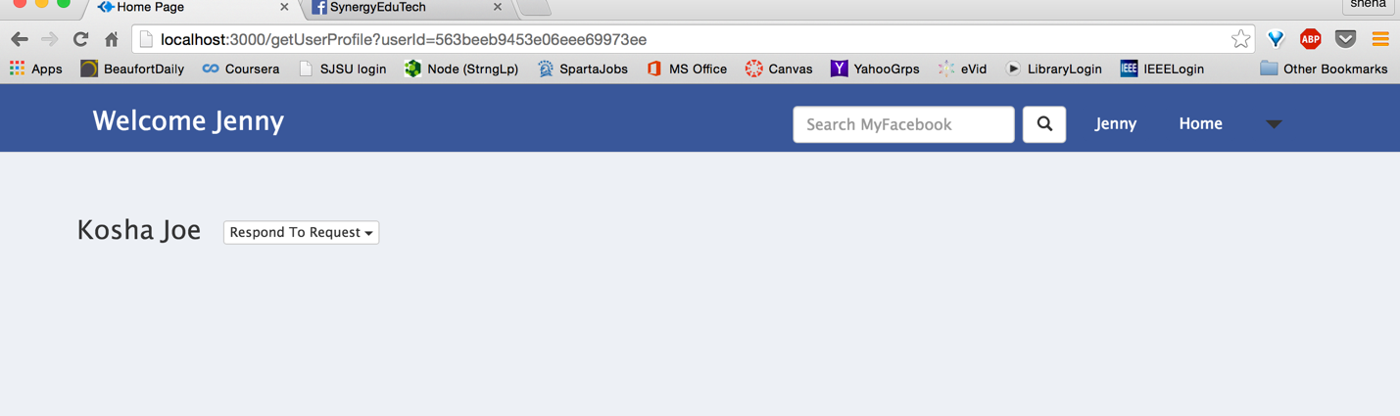

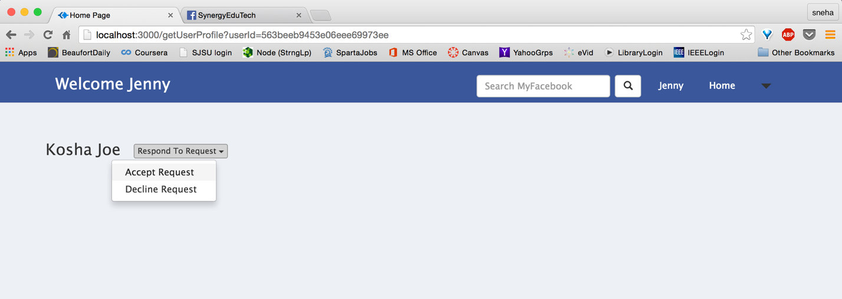

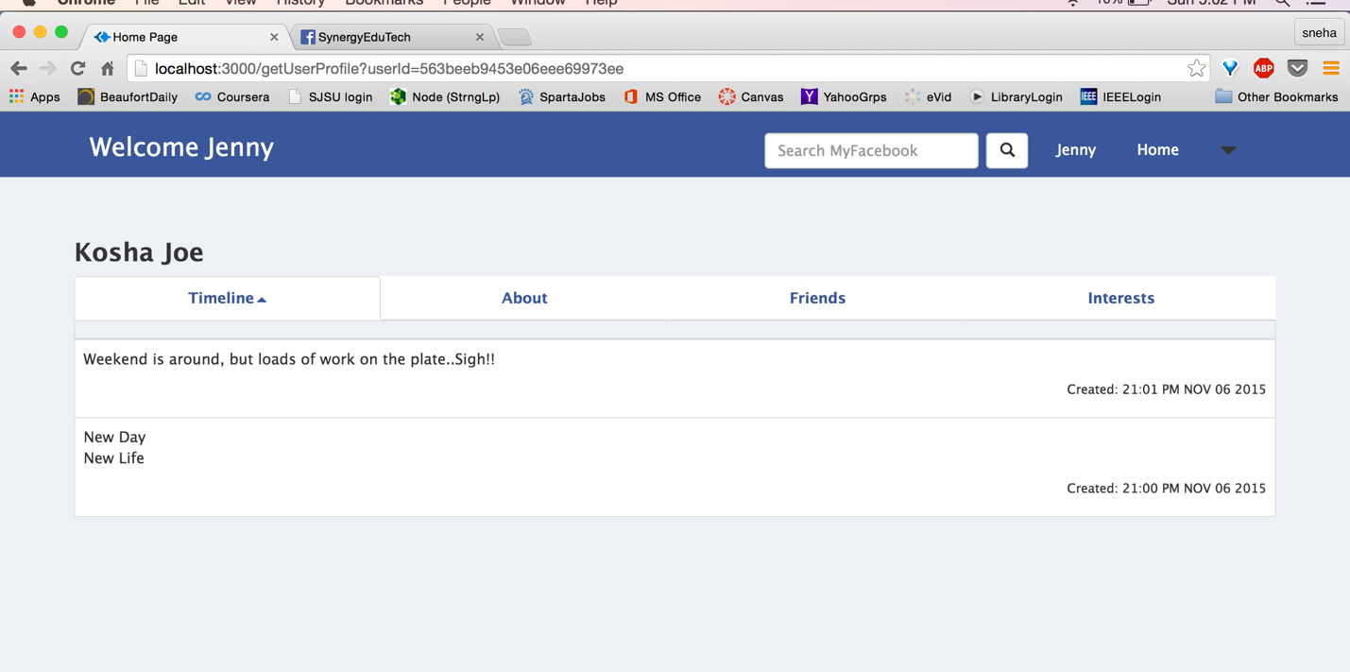

* + - Reject friend request

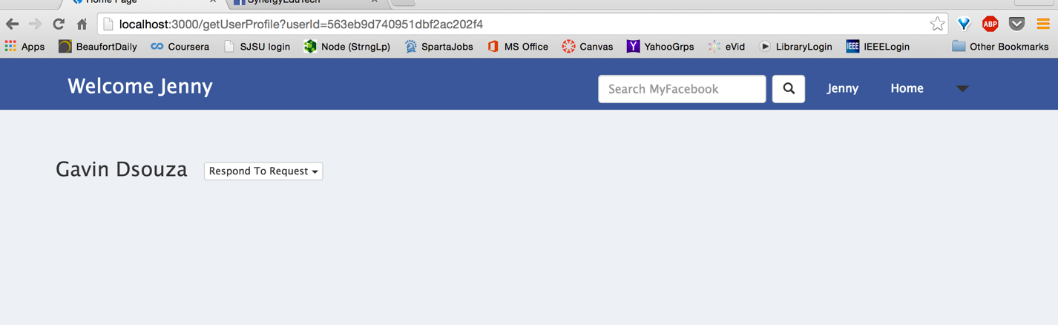

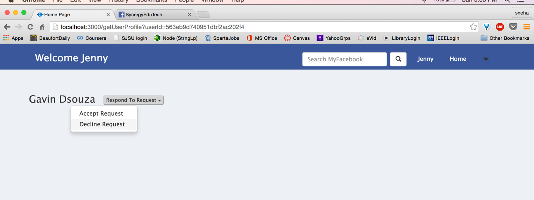

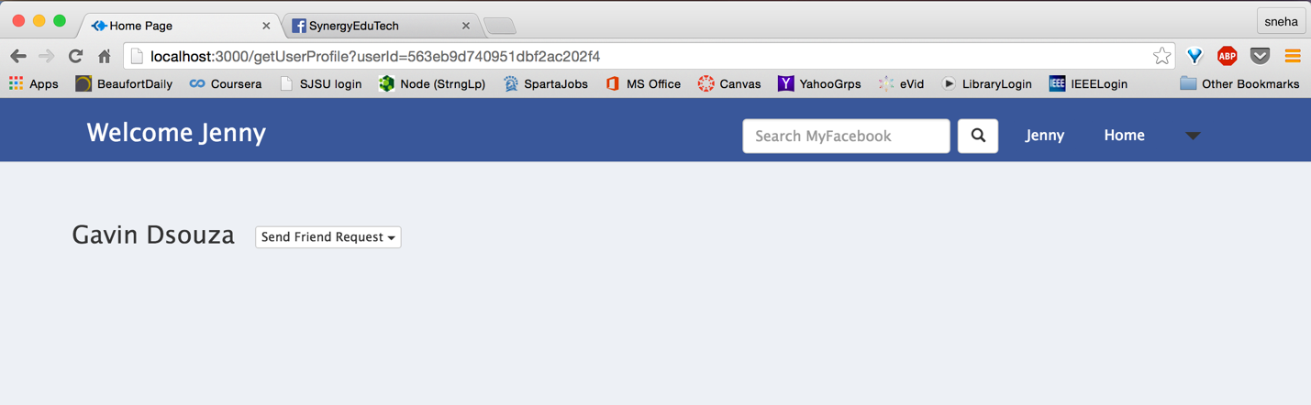

* + Change pending request

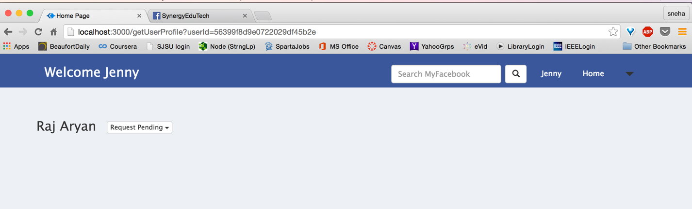

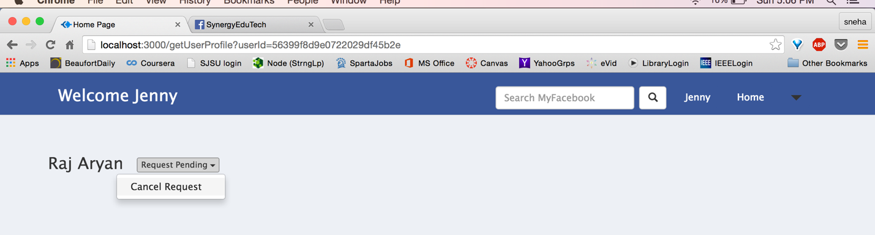

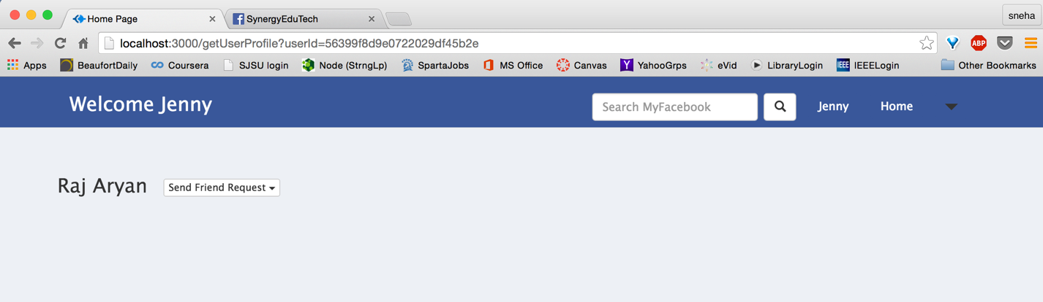

* Create Interest:

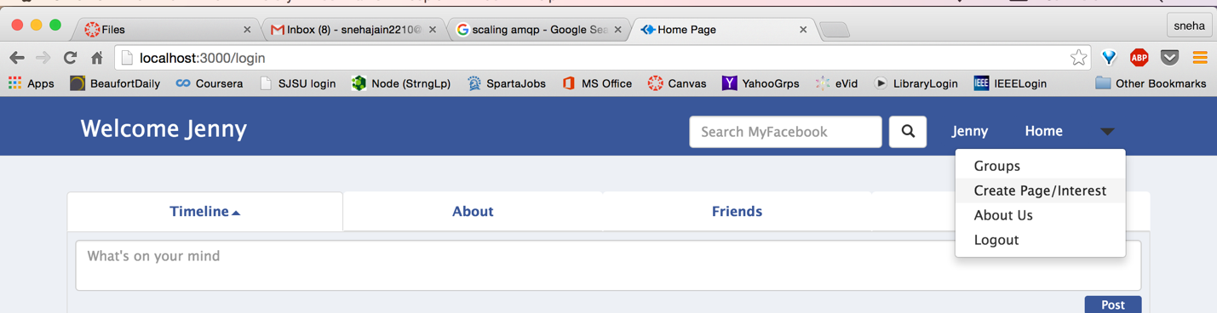

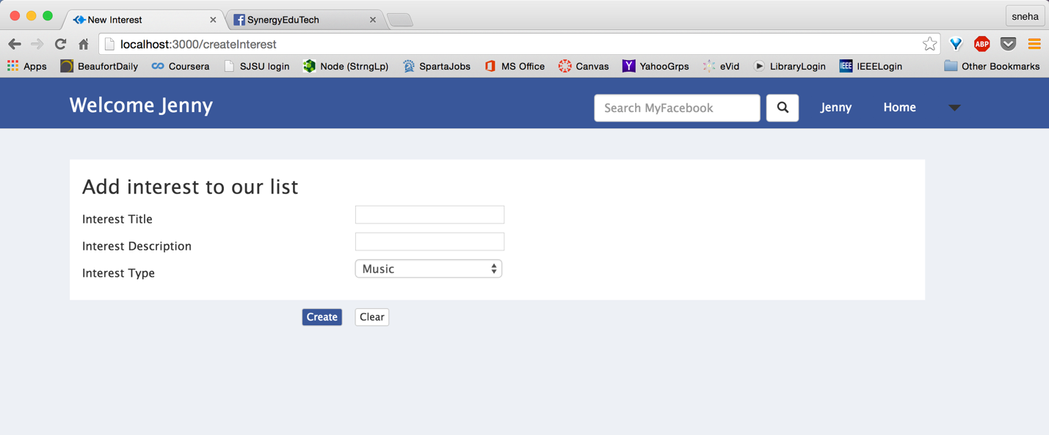

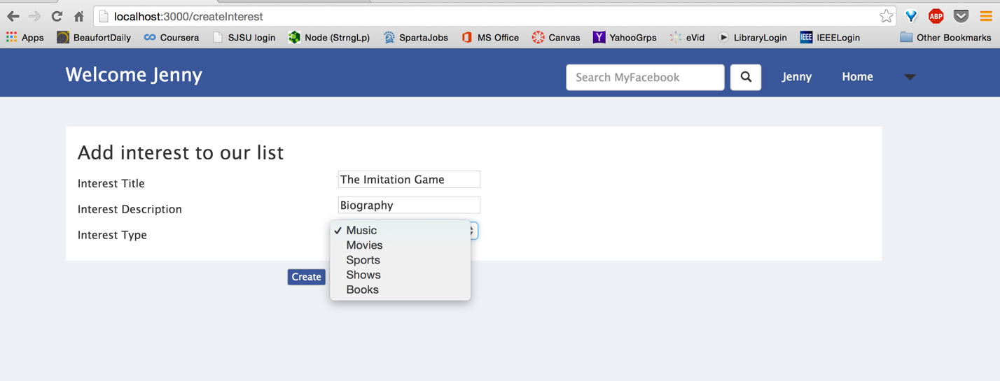

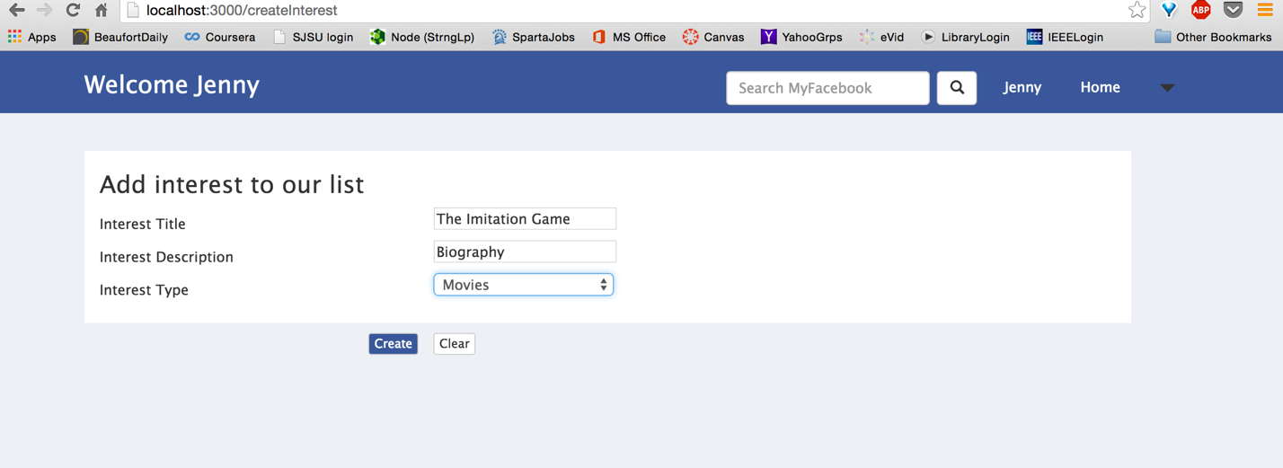

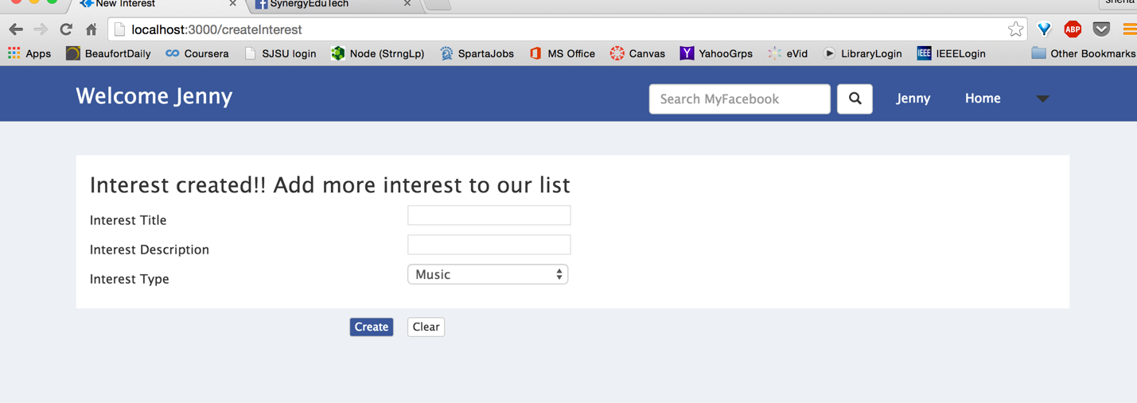

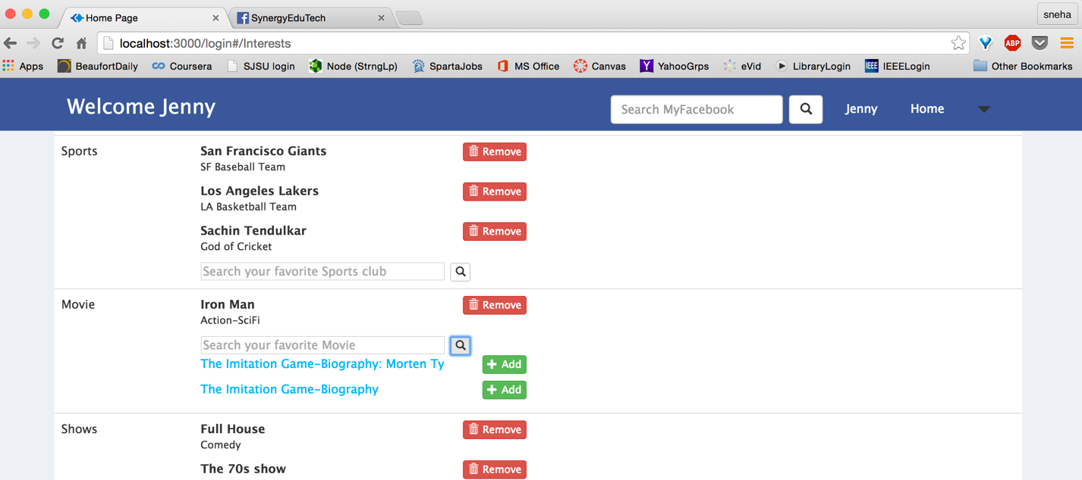

* About us page:

Can be accessed using link on login page (**Learn More about MyFacebook here**)

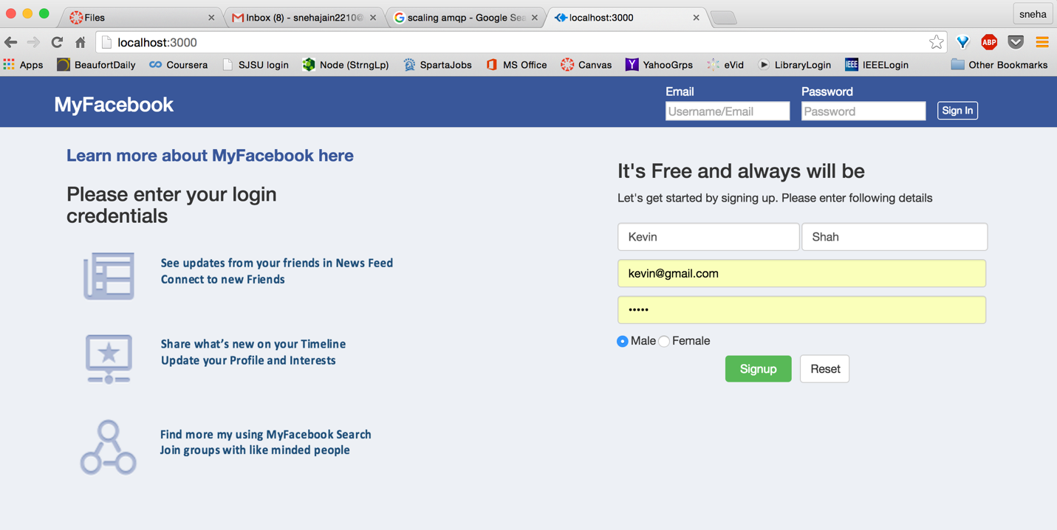

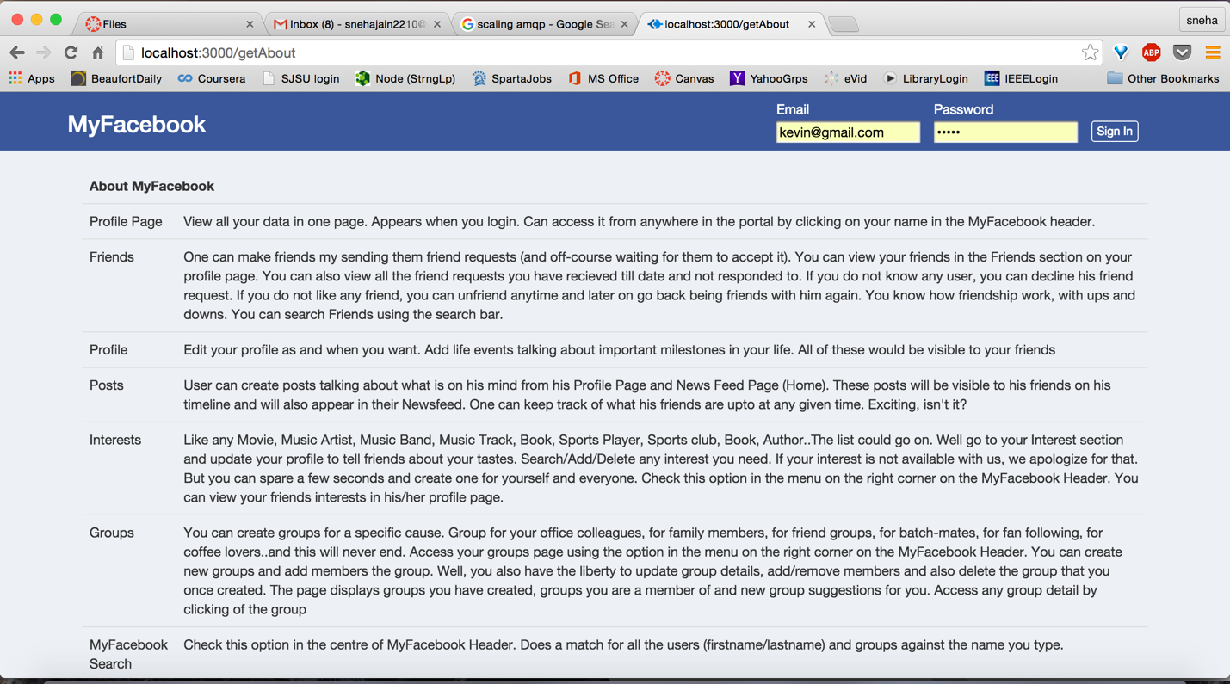

For logged in users, use option in header dropdown

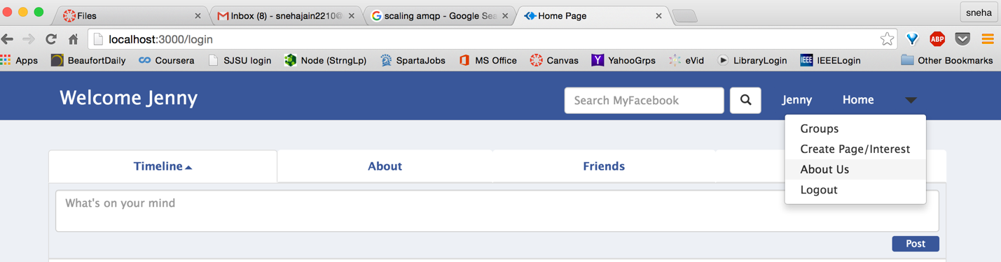

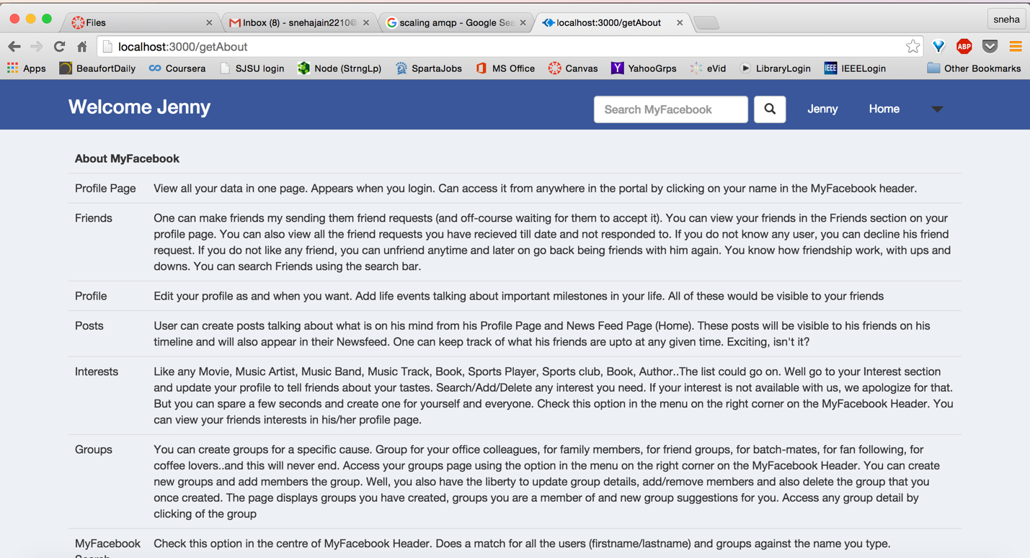

* Exception Handling:
  + No such user

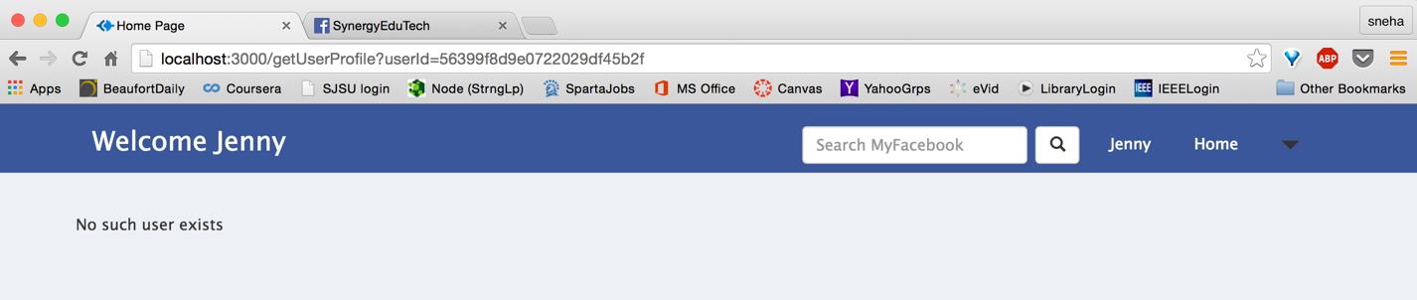

* + No such group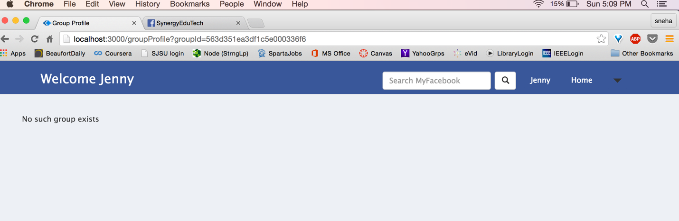
  + Page doesn’t exist

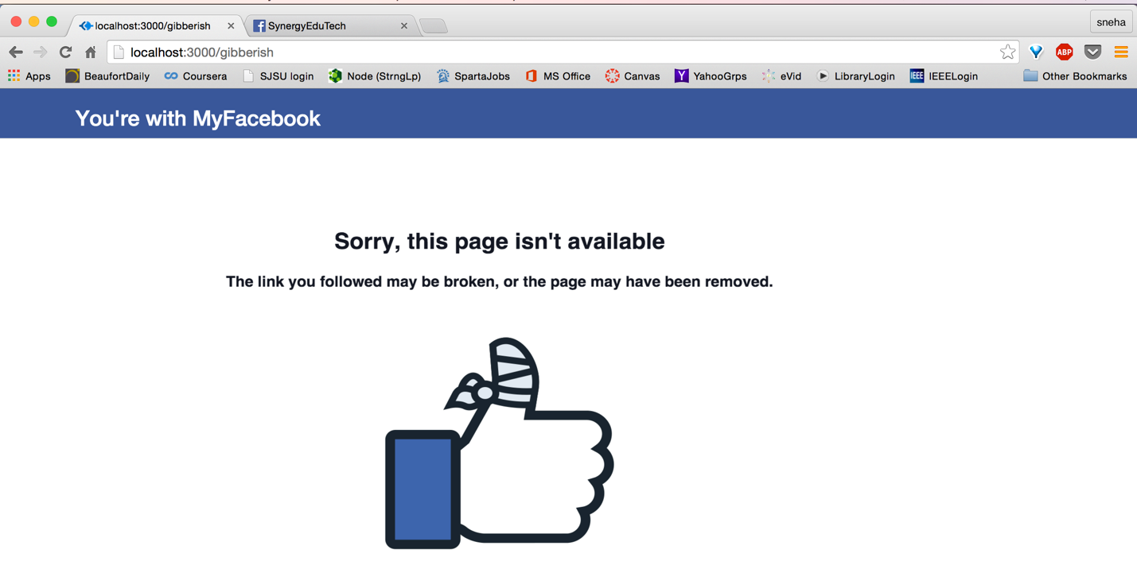

* + Login required

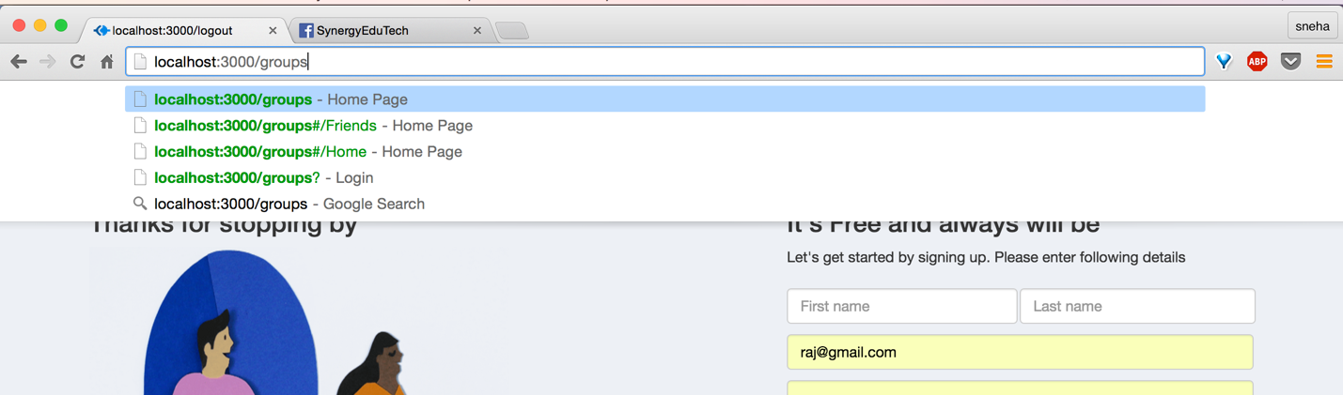

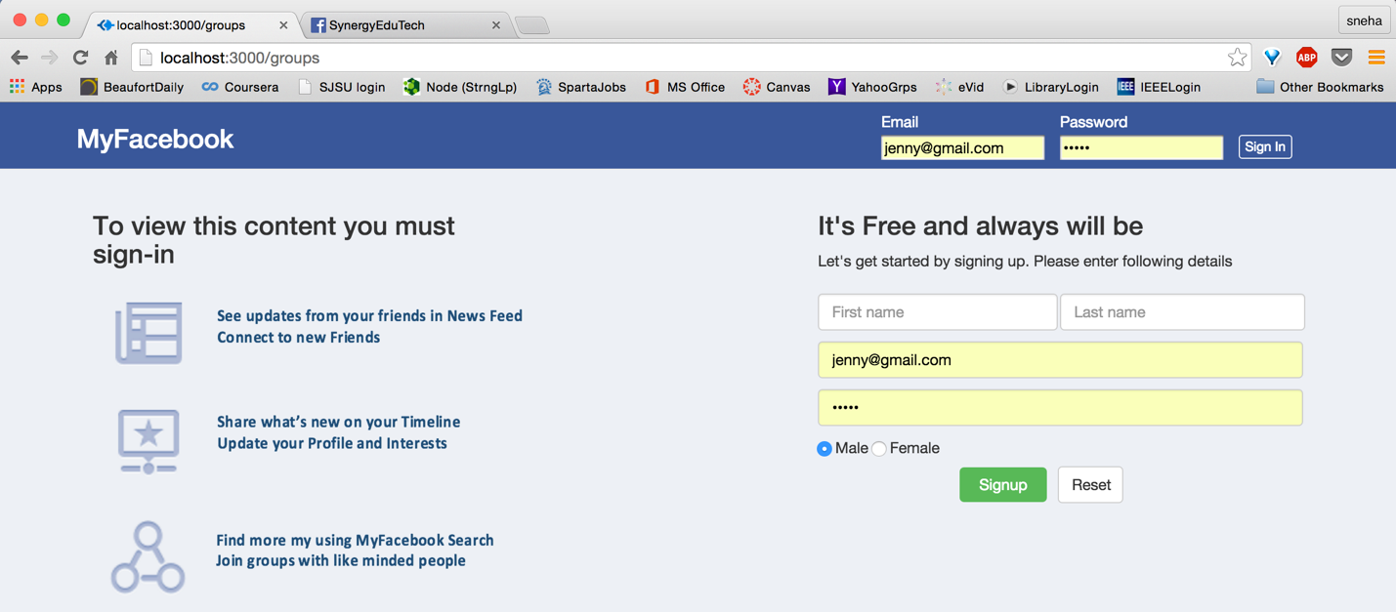

1. Performance

As measured using apache-jmeter application

|  |  |  |  |  |
| --- | --- | --- | --- | --- |
|  | Rabbit throughput | Avg response time | Normal Throughput | Avg response time |
| 100 users | 98.3/sec | 0.980 sec | 98.6/sec | 0.986 sec |
| 200 users | 177.8/sec | 0.889 sec | 188.9/sec | 0.945 sec |
| 300 users | 222.6/sec | 0.742 sec | 271.0/sec | 0.903 sec |
| 400 users | 240.0/sec | 0.600 sec | 305.8/sec | 0.765 sec |
| 500 users | 251.0/sec | 0.502 sec | 382.3/sec | 0.765 sec |

Throughput screenshots with RabbitMQ:

500 concurrent users

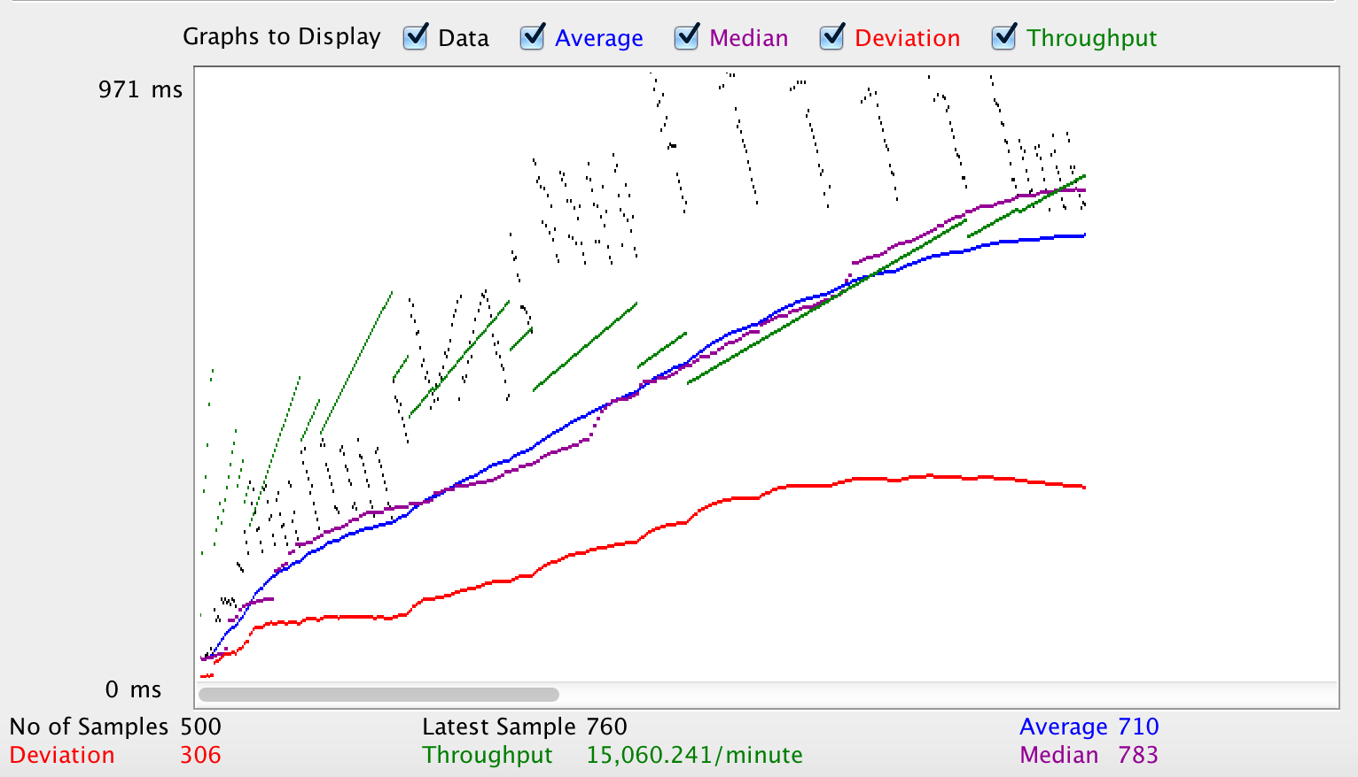

400 concurrent users

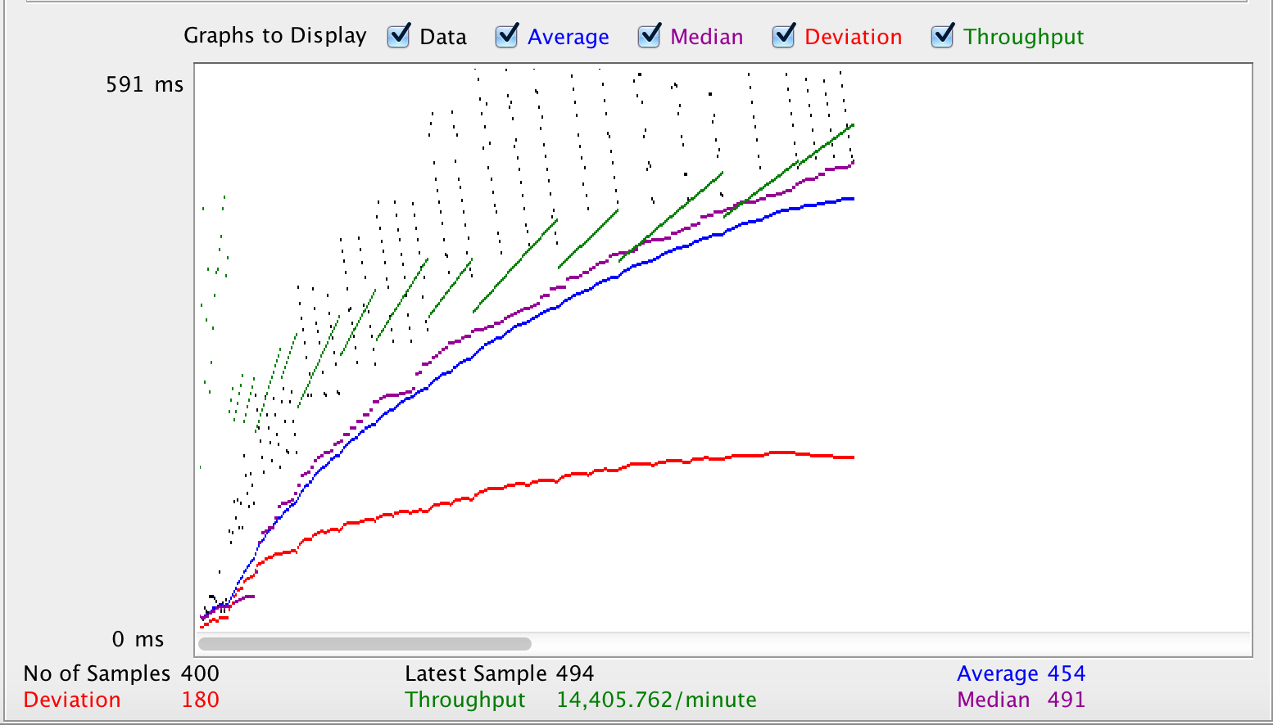

300 concurrent users

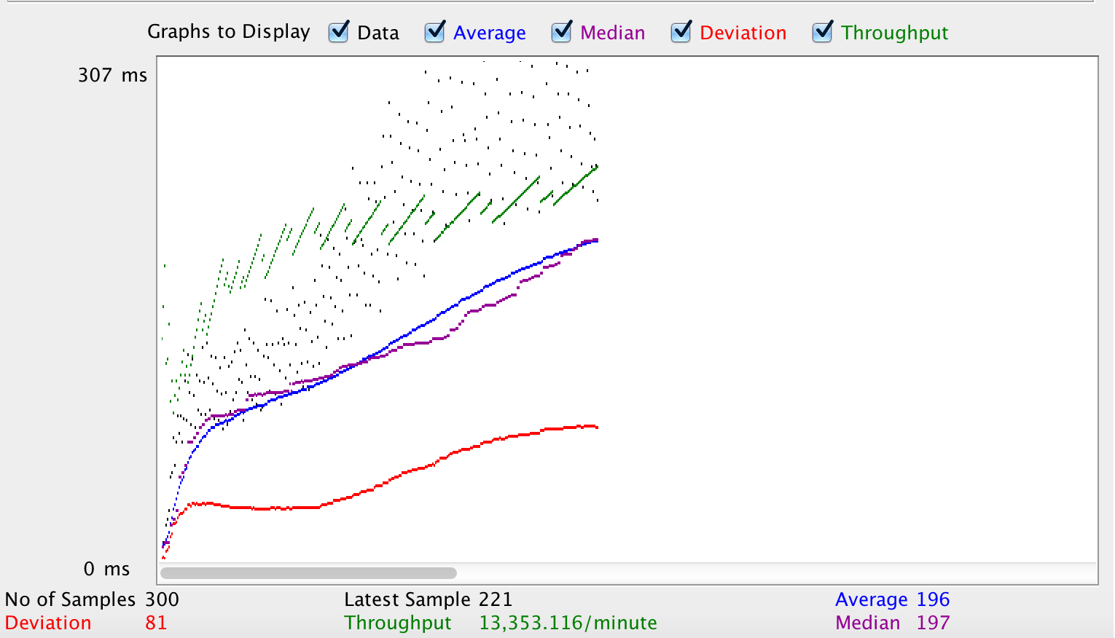

200 concurrent users

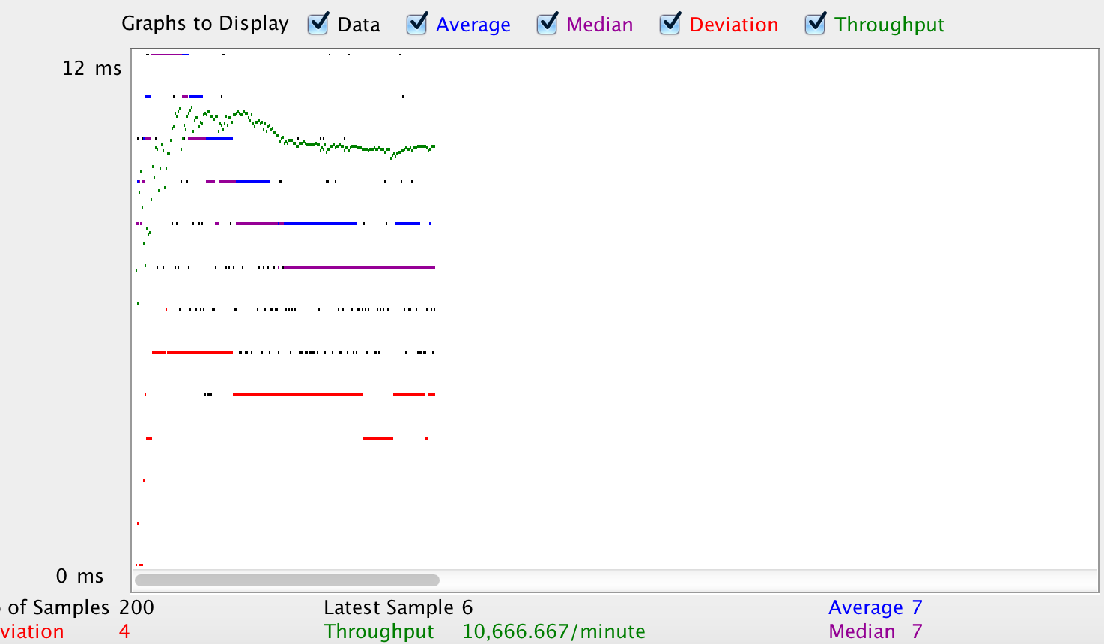

100 concurrent users

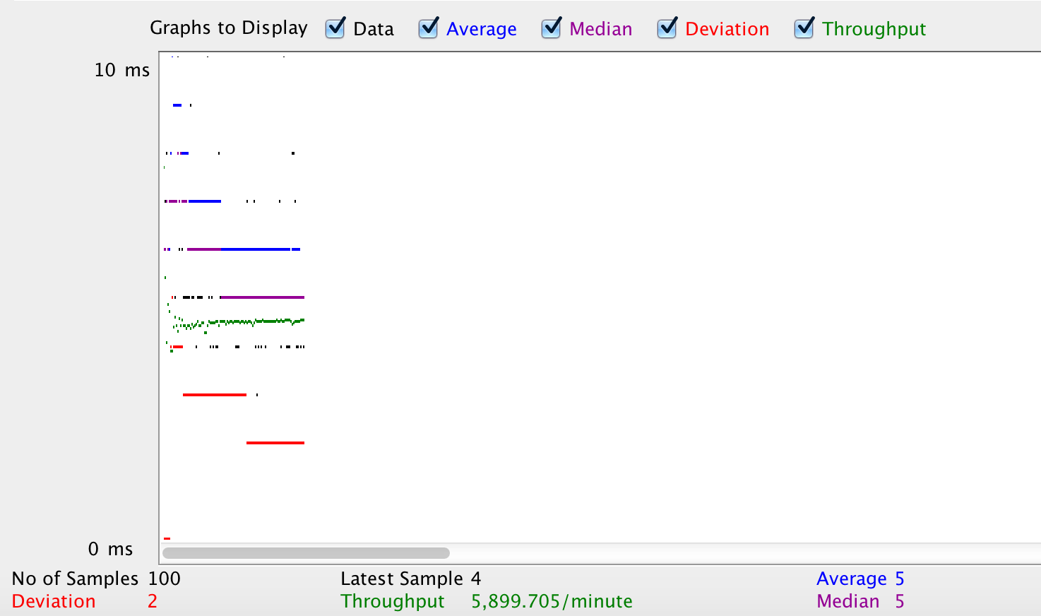

Throughput screenshots without RabbitMQ:

500 concurrent users

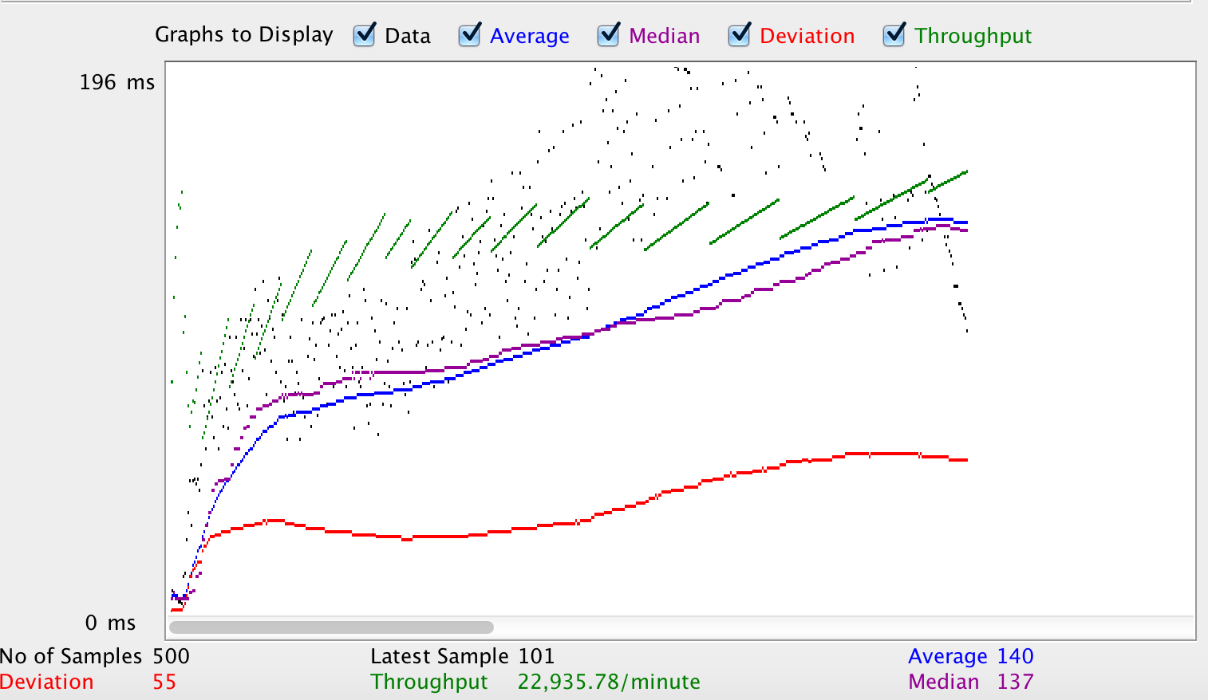

400 concurrent users

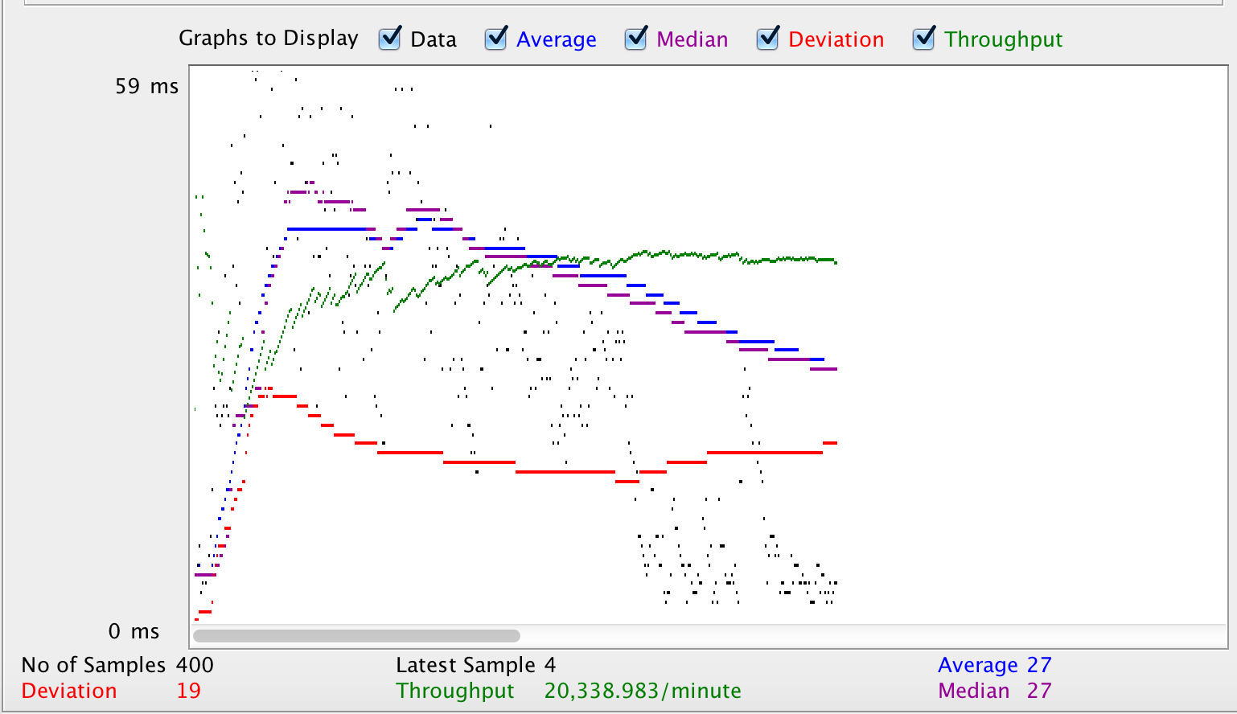

300 concurrent users

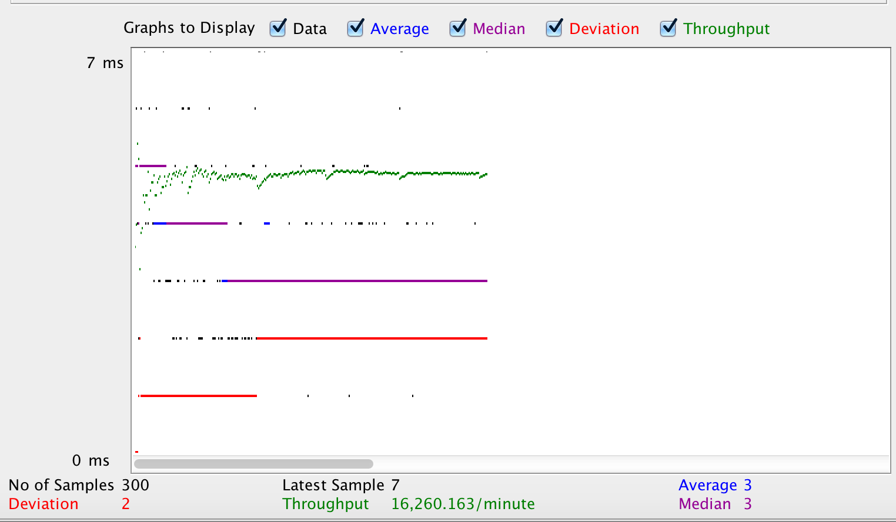

200 concurrent users

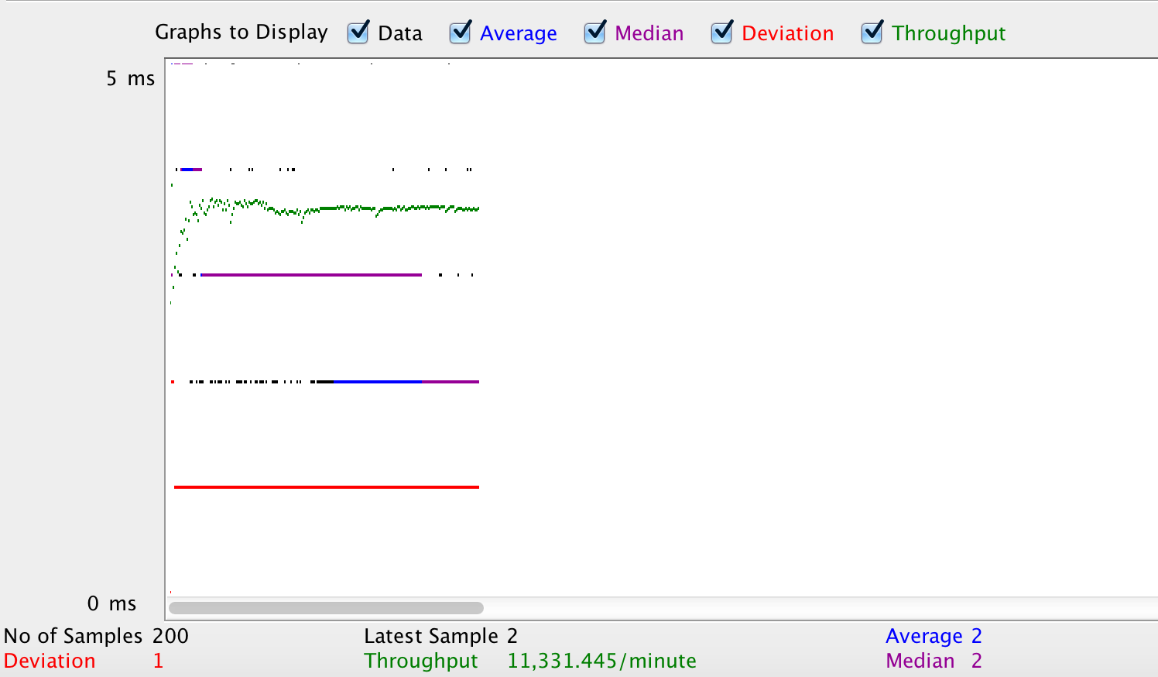

100 concurrent users

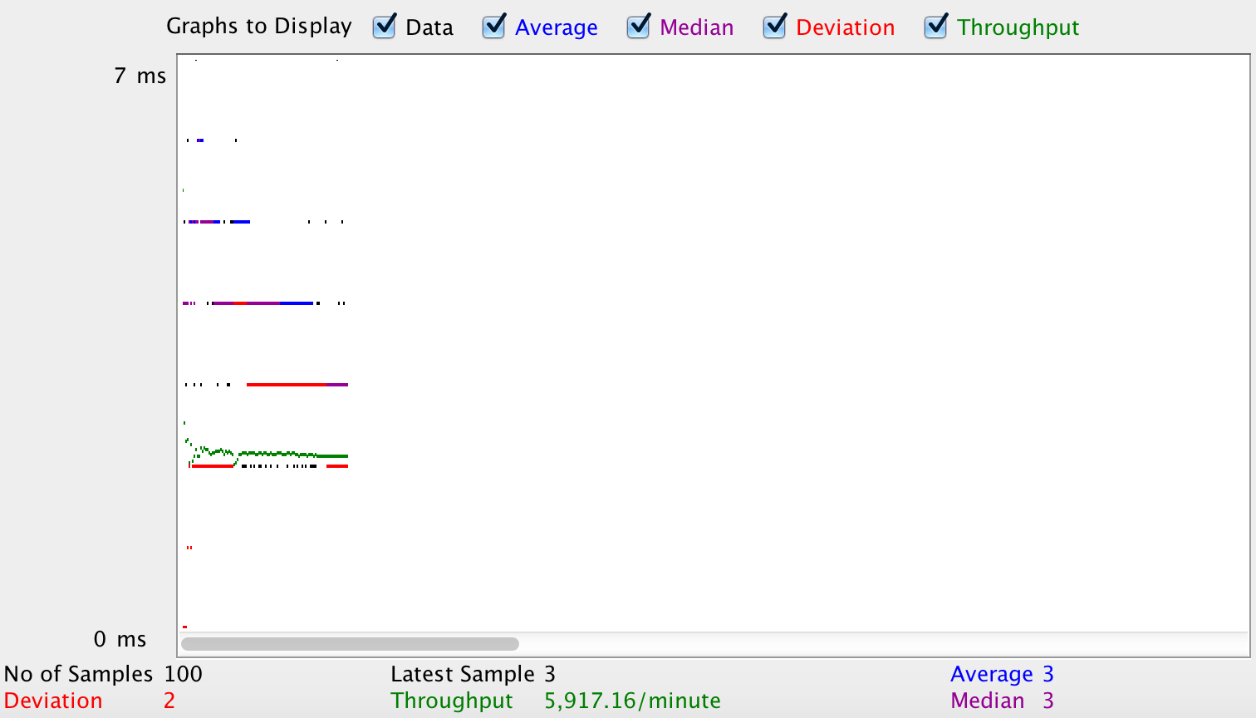

1. Answers
   1. **How to achieve horizontal scalability with single RabbitMQ Server? Elaborate on the results of throughput with and without using RabbitMQ. If you find any increase/decrease in the throughput, explain the reason for the same.**

Using RabbitMQ, we can have multiple client (publishers) applications sending messages to the server (subscribers). Each message can be routed to a specific queue and this can be distributed according to the application requirement to balance application load. Since the publishers and subscribers do not interact directly, we can modify each without having to change the other. We decouple the producers from the consumers. This makes our application capable to scale to include more servers at each end. Number of publishers can increase owing to increase in users/expansion. Number of subscribers of the application can increase to better balance application load.

The throughput from the load tests performed above, do not reflect RabbitMQ efficiency, however with increasing number of requests, the throughput is clearly increasing. Moreover, the performance will be much better with increasing concurrent requests routed to different queues.

|  |  |  |  |  |
| --- | --- | --- | --- | --- |
|  | Rabbit throughput | Avg response time | Normal Throughput | Avg response time |
| 100 users | 98.3/sec | 0.980 sec | 98.6/sec | 0.986 sec |
| 200 users | 177.8/sec | 0.889 sec | 188.9/sec | 0.945 sec |
| 300 users | 222.6/sec | 0.742 sec | 271.0/sec | 0.903 sec |
| 400 users | 240.0/sec | 0.600 sec | 305.8/sec | 0.765 sec |
| 500 users | 251.0/sec | 0.502 sec | 382.3/sec | 0.765 sec |

* 1. **Explain the strategy used in implementing Sessions in this Lab. Compare your Sessions strategy with default express Sessions. Describe which Strategy is better.**

Sessions are stored using server session strategy. The session data is stored in database (mongoDB) using mongo-store. This approach is better than default express sessions as it gives scope for horizontal scalability.

With default express sessions, session data is stored in MemoryStore that uses application RAM. Thus memory usage keeps on increasing with every new session and might run out of memory in case of multiple sessions. If the application is restarted, the session data is lost as RAM data is not persistent data. In case of a cluster, the session data cannot be shared, thus restricting horizontal scalability.

If your application has multiple servers, saving session in database will make your session available to all the servers. In case of a load balancing scheme, user request can be responded by any available server and is not tied to only one server. If any server is restarted, the session will still be persisted, which doesn’t happen in express-sessions.

* 1. **Describe the type of encryption algorithm used to store passwords in this lab and the reason to use it.**

Passwords are hashed before storing them to the database. The hash function uses sha512 (Secure Hash Algorithm) to create the hash. The function uses a salt, email for this application, along with the password to create the hash. Hashing a password is better than encrypting because with encryption, the original text can be retrieved from the encrypted text. In case of hash, only if you have the original text and salt, you can create the hashed value and check the same against the value stored in database. Thus, this way passwords and other confidential data stored should be hashed before storing.